http://www.history.com/news/ask-history/what-part-of-africa-did-most-slaves-come-from



What part of Africa did most slaves come from?

**Audio File**

African Slave Trade.

Slavery became an industry for the first time in history when millions of African men and women were sold as slaves to Europeans.

Though exact totals will never be known, the transatlantic slave trade is believed to have forcibly displaced some 12.5 million Africans between the 17th and 19th centuries; some 10.6 million survived the infamous Middle Passage across the Atlantic. Though descendants of these enslaved Africans now make up considerable segments of the population in the United States, Brazil and many Caribbean islands, written records of their ancestors’ origins are difficult—if not impossible—to find. Through extensive research, however, scholars have been able to make educated guesses about where many of the slaves brought to the New World originated.

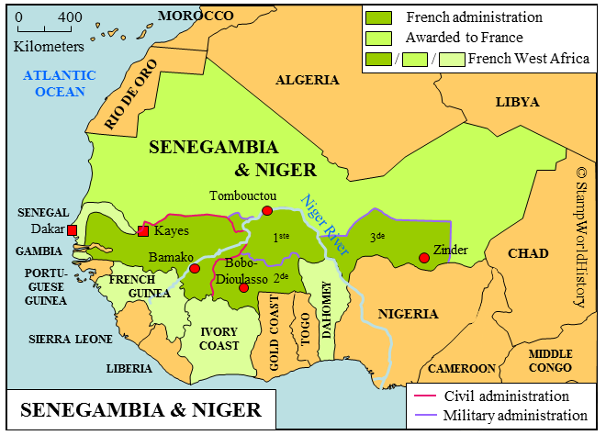

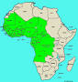Slaves brought to the United States represented about 3.6 percent of the total number of Africans transported to the New World, or around 388,000 people—considerably less than the number transported to colonies in the Caribbean (including more than 1.2 million to Jamaica alone) or to Brazil (4.8 million). Of those Africans who arrived in the United States, **nearly half came from two regions:** **Senegambia,** the area comprising the Senegal and Gambia Rivers and the land between them, or today’s Senegal, Gambia, Guinea-Bissau and Mali; and **west-central Africa**, including what is now Angola, Congo, the Democratic Republic of Congo and Gabon. The Gambia River, running from the Atlantic into Africa, was a key waterway for the slave trade; at its height, about one out of every six West African slaves came from this area.

Egypt

West-Central

Africa

In addition to the nearly 50 percent of the total number of enslaved Africans in the United States from these two regions, a considerable number of slaves had their origins on the so-called Gold Coast or “Slave Coast,” which is now the West African nation of Ghana, as well as neighboring parts of the Windward Coast, now Ivory Coast. Others originated in the Bight of Biafra (including parts of present-day eastern Nigeria and Cameroon), an inlet of the Atlantic on Africa’s western coast that was a hub of extensive slave-dealing operations.



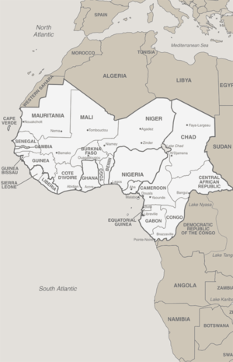

Egypt

West-Central

Africa

Angola

# The Transatlantic Slave Trade Database

**Audio File**



Egypt

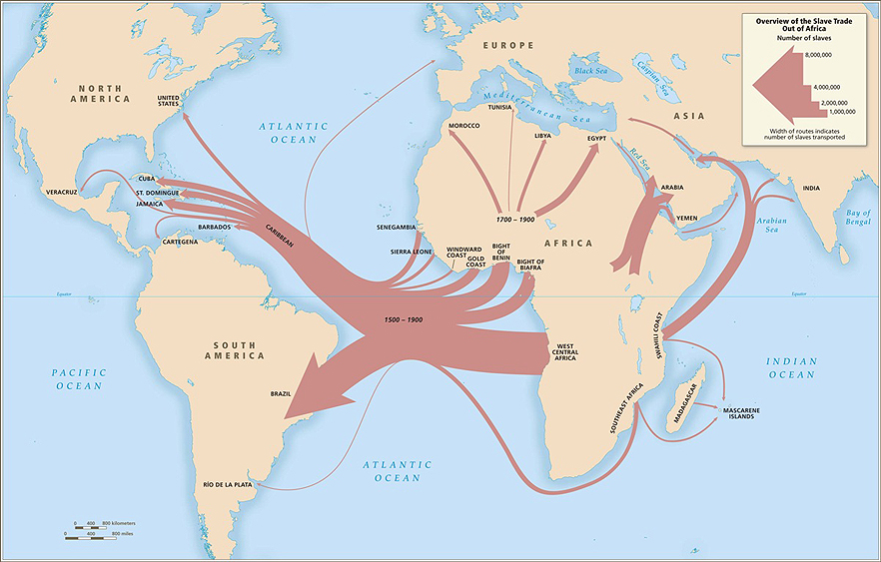https://www.neh.gov/news/voyages-the-transatlantic-slave-trade-database

SOLVING 'THE GREATEST MYSTERY IN THE HISTORY OF THE WEST.

Until very recently, many African Americans were unable to trace their ancestors’ first steps in America because so few credible records were available.

That absence constitutes “the greatest mystery in the history of the West,” according to Henry Louis Gates, Jr., Harvard University professor and producer of the PBS documentary African American Lives. “Their ancestries, their identities, their stories were lost in the ships that carried them across the Atlantic.”

Or so it seemed. Often records did exist – but they were isolated in scores of locations in a number of countries. The NEH-supported "Voyages: The Transatlantic Slave Trade Database" has allowed those records to be combined and collated so that the public can follow for the first time the routes of slave ships that transported 12.5 million Africans across the Atlantic from the 16th through the 19th century.

The free online database, housed at Emory University, incorporates 40 years of archival research and brings together images, maps, voyage logs and other records of about 35,000 transatlantic slave ship crossings. Records of trade routes offer historians a fuller picture of the economic and political dimensions of the slave trade. For example, users can search for information about a specific voyage or a large subset of data, such as all voyages under the Portuguese flag.

The site’s African Names Databases identifies 67,000 Africans, bound for slavery in North and South America, but liberated after their ships were stopped by the Royal Navy. These records are sortable by name, gender origin, and place of embarkation.

Professor Gates has credited the “Voyages” project with shedding important light on the history of 12.5 million slaves. "The multi-decade and collaborative project that brought us [the Voyages] site has done more to reverse the Middle Passage than any other single act of scholarship possibly could," he said.

Read more about the Trans-Atlantic Slave Trade Database in Humanities magazine: "Gross Injustice: The Slave Trade by the Numbers."

https://en.wikipedia.org/wiki/Atlantic_slave_trade#Ghana.

**Audio File**



Atlantic slave trade.

The Atlantic slave trade or transatlantic slave trade took place across the Atlantic Ocean from the 15th through the 19th centuries. **The vast majority of those who were enslaved and transported to the New World**, mainly on the triangular trade route and its Middle Passage, **were Africans from the central and western parts of the continent** who had been sold by other West Africans to Western European slave traders (with a small minority being captured directly by the slave traders in coastal raids), and brought to the Americas. The South Atlantic and Caribbean economic system centered on producing commodity crops, making goods and clothing to sell in Europe, and increasing the numbers of African slaves brought to the New World. This was crucial to those western European countries which, in the late 17th and 18th centuries, were vying with each other to create overseas empires.

The Portuguese were the first to engage in the New World slave trade in the 16th century. Between 1418 and the 1470s, the Portuguese launched a series of exploratory expeditions that remapped the oceans south of Portugal, charting new territories that one explorer described as "oceans where none have ever sailed before." In 1526, the Portuguese completed the first transatlantic slave voyage from Africa to the Americas, and other countries soon followed. Shipowners regarded the slaves as cargo to be transported to the Americas as quickly and cheaply as possible, there to be sold to labour in coffee, tobacco, cocoa, sugar and cotton plantations, gold and silver mines, rice fields, construction industry, cutting timber for ships, in skilled labour, and as domestic servants. The first Africans imported to the English colonies were classified as "indentured servants", like workers coming from England, and also as "apprentices for life". By the middle of the 17th century, slavery had hardened as a racial caste; they and their offspring were legally the property of their owners, and children born to slave mothers were slaves. As property, the people were considered merchandise or units of labour, and were sold at markets with other goods and services.

The major Atlantic slave trading nations, ordered by trade volume, were: the Portuguese, the British, the French, the Spanish, and the Dutch Empire. Several had established outposts on the African coast where they purchased slaves from local African leaders. These slaves were managed by a factor who was established on or near the coast to expedite the shipping of slaves to the New World. Slaves were kept in a factory while awaiting shipment. Current estimates are that about 12 million Africans were shipped across the Atlantic,[6] although the number purchased by the traders is considerably higher, as the passage had a high death rate. Near the beginning of the nineteenth century, various governments acted to ban the trade, although illegal smuggling still occurred. In the early twenty-first century, several governments issued apologies for the transatlantic slave trade.

<https://en.wikipedia.org/wiki/Leprosy>

**Audio File**



Leprosy.

From Wikipedia, the free encyclopedia.

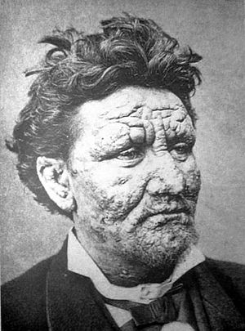**Leprosy**, also known as **Hansen's disease** (**HD**), is a [long-term](https://en.wikipedia.org/wiki/Chronic_(medicine)) infection by the [bacteria](https://en.wikipedia.org/wiki/Bacteria) [*Mycobacterium leprae*](https://en.wikipedia.org/wiki/Mycobacterium_leprae) or [*Mycobacterium lepromatosis*](https://en.wikipedia.org/wiki/Mycobacterium_lepromatosis).Initially, infections are without symptoms and typically remain this way for 5 to 20 years. Symptoms that develop include [granulomas](https://en.wikipedia.org/wiki/Granuloma" \o "Granuloma) of the [nerves](https://en.wikipedia.org/wiki/Peripheral_nervous_system), [respiratory tract](https://en.wikipedia.org/wiki/Respiratory_tract), skin, and eyes. This may result in a lack of ability to feel pain, thus loss of parts of extremities due to repeated injuries or infection due to unnoticed wounds. Weakness and poor eyesight may also be present.

Leprosy is spread between people. This is thought to occur through a cough or contact with fluid from the nose of an infected person. Leprosy occurs more commonly among those living in poverty. Contrary to popular belief, it is not highly contagious.The two main types of disease are based on the number of bacteria present: paucibacillary and multibacillary. The two types are differentiated by the number of [poorly pigmented](https://en.wikipedia.org/wiki/Hypopigmentation), numb skin patches present, with paucibacillary having five or fewer and multibacillary having more than five. The diagnosis is confirmed by finding [acid-fast](https://en.wikipedia.org/wiki/Acid-fast) bacilli in a biopsy of the skin or by detecting the DNA using [polymerase chain reaction](https://en.wikipedia.org/wiki/Polymerase_chain_reaction).

Leprosy is curable with a treatment known as multidrug therapy. Treatment for paucibacillary leprosy is with the medications [dapsone](https://en.wikipedia.org/wiki/Dapsone" \o "Dapsone) and [rifampicin](https://en.wikipedia.org/wiki/Rifampicin) for six months. Treatment for multibacillary leprosy consists of [rifampicin](https://en.wikipedia.org/wiki/Rifampicin" \o "Rifampicin), [dapsone](https://en.wikipedia.org/wiki/Dapsone" \o "Dapsone), and [clofazimine](https://en.wikipedia.org/wiki/Clofazimine) for 12 months. A number of other antibiotics may also be used. These treatments are provided free of charge by the [World Health Organization](https://en.wikipedia.org/wiki/World_Health_Organization). Globally in 2012, the number of chronic cases of leprosy was 189,000, down from some 5.2 million in the 1980s. The number of new cases was 230,000. Most new cases occur in 16 countries, with India accounting for more than half. In the past 20 years, 16 million people worldwide have been cured of leprosy. About 200 cases are reported per year in the United States.

Leprosy has affected humanity for thousands of years. The disease takes its name from the [Latin](https://en.wikipedia.org/wiki/Latin) word *lepra*, which means "scaly", while the term "Hansen's disease" is named after the physician [Gerhard Armauer Hansen](https://en.wikipedia.org/wiki/Gerhard_Armauer_Hansen). Separating people by placing them in [leper colonies](https://en.wikipedia.org/wiki/Leper_colony) still occurs in places such as India, China,[]](https://en.wikipedia.org/wiki/Leprosy#cite_note-10) and Africa. However, most colonies have closed, since leprosy is not very contagious. [Social stigma](https://en.wikipedia.org/wiki/Leprosy_stigma) has been associated with leprosy for much of history, which continues to be a barrier to self-reporting and early treatment. Some consider the word "leper" offensive, preferring the phrase "person affected with leprosy". [World Leprosy Day](https://en.wikipedia.org/wiki/World_Leprosy_Day) was started in 1954 to draw awareness to those affected by leprosy.

## Signs and symptoms[[edit](https://en.wikipedia.org/w/index.php?title=Leprosy&action=edit&section=1" \o "Edit section: Signs and symptoms)]

Leprosy is mostly a [granulomatous](https://en.wikipedia.org/wiki/Granuloma" \o "Granuloma) disease of the [peripheral nerves](https://en.wikipedia.org/wiki/Peripheral_nervous_system) and [mucosa](https://en.wikipedia.org/wiki/Mucous_membrane) of the [upper respiratory tract](https://en.wikipedia.org/wiki/Upper_respiratory_tract); skin lesions (light or dark patches) are the primary external sign.[[14]](https://en.wikipedia.org/wiki/Leprosy#cite_note-Sherris-14) If untreated, leprosy can progress and cause permanent damage to the skin, nerves, limbs, and eyes. Contrary to folklore, leprosy does not cause body parts to fall off, although they can become numb or diseased as a result of secondary infections; these occur as a result of the body's defenses being compromised by the primary disease. Secondary infections, in turn, can result in tissue loss, causing fingers and toes to become shortened and deformed, as cartilage is absorbed into the body.

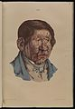

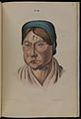

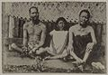

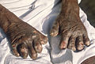

A 13-year-old boy with severe leprosy

woman with leprous lesions

A 26-year-old woman with leprous lesions

Hands deformed by leprosy

## History[[edit](https://en.wikipedia.org/w/index.php?title=Leprosy&action=edit&section=14)]

*Main article:*[*History of leprosy*](https://en.wikipedia.org/wiki/History_of_leprosy)

Using comparative genomics, in 2005, geneticists traced the origins and worldwide distribution of leprosy from East Africa or the Near East along human migration routes. They found four strains of *M. leprae* with specific regional locations. Strain 1 occurs predominantly in Asia, the Pacific region, and East Africa; strain 4, in West Africa and the Caribbean; strain 3 in Europe, North Africa, and the Americas; and strain 2 only in Ethiopia, Malawi, Nepal/north India, and New Caledonia.

On the basis of this, they offer a map of the dissemination of leprosy in the world. This confirms the spread of the disease along the migration, colonisation, and slave trade routes taken from East Africa to India, West Africa to the New World, and from Africa into Europe and vice versa.

The oldest skeletal evidence for the disease was found in the human remains from the archaeological sites of Balathal and [Harappa](https://en.wikipedia.org/wiki/Harappa), in India and Pakistan, respectively.

Although retrospectively identifying descriptions of leprosy-like symptoms is difficult, what appears to be leprosy was discussed by Hippocrates in 460 BC. In 1846, Francis Adams produced *The Seven Books of Paulus Aegineta* which included a commentary on all medical and surgical knowledge and descriptions and remedies to do with leprosy from the Romans, Greeks, and Arabs.

Interpretations of the presence of leprosy have been made on the basis of descriptions in ancient Indian (Atharva Veda and Kausika Sutra), Greek, and Middle Eastern documentary sources that describe skin afflictions.

Skeletal remains from the second millennium BC, discovered in 2009, represent the oldest documented evidence for leprosy. Located at Balathal, in Rajasthan, northwest India, the discoverers suggest that if the disease did migrate from Africa to India, during the third millennium BC "at a time when there was substantial interaction among the Indus Civilization, Mesopotamia, and Egypt, there needs to be additional skeletal and molecular evidence of leprosy in India and Africa so as to confirm the African origin of the disease. A proven human case was verified by DNA taken from the shrouded remains of a man discovered in a tomb next to the Old City of Jerusalem dated by radiocarbon methods to 1–50 AD.

The causative agent of leprosy, *M. leprae*, was discovered by [G. H. Armauer Hansen](https://en.wikipedia.org/wiki/Gerhard_Armauer_Hansen) in Norway in 1873, making it the first bacterium to be identified as causing disease in humans.[[65]](https://en.wikipedia.org/wiki/Leprosy#cite_note-Irgens_2002-65) The first effective treatment ([promin](https://en.wikipedia.org/wiki/Promin" \o "Promin)) became available in the 1940s. In the 1950s, dapsone was introduced. The search for further effective antileprosy drugs led to the use of clofazimine and rifampicin in the 1960s and 1970s. Later, Indian scientist Shantaram Yawalkar and his colleagues formulated a combined therapy using rifampicin and dapsone, intended to mitigate bacterial resistance. MDT combining all three drugs was first recommended by the [WHO](https://en.wikipedia.org/wiki/World_Health_Organization) in 1981. These three antileprosy drugs are still used in the standard MDT regimens.

Leprosy was once believed to be highly contagious and was treated with [mercury](https://en.wikipedia.org/wiki/Mercury_(element))—all of which applied to [syphilis](https://en.wikipedia.org/wiki/Syphilis), which was first described in 1530. Many early cases thought to be leprosy could actually have been syphilis Resistance has developed to initial treatment. Until the introduction of MDT in the early 1980s, the disease could not be diagnosed and treated successfully within the community.

[Japan](https://en.wikipedia.org/wiki/National_Hansen%27s_Disease_Museum_(Japan)) still has sanatoriums (although Japan's sanatoriums no longer have active leprosy cases, nor are survivors held in them by law).

The importance of the nasal mucosa in the transmission of *M leprae* was recognized as early as 1898 by Schäffer, in particular, that of the ulcerated mucosa.

Angola

West-Central

Africa