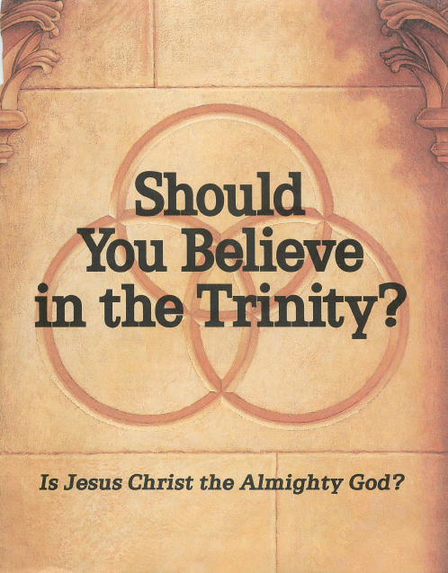

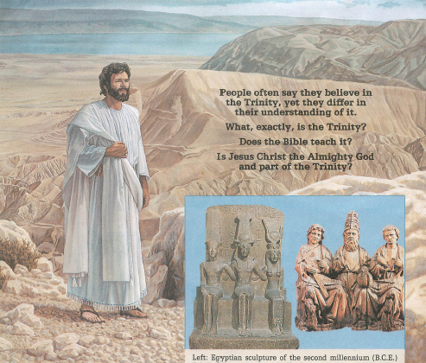
P
People often say they believe in
the Trinity, yet they differ in
their understanding of it.
What, exactly, is the Trinity?
Does the Bible teach it?

Is Jesus Christ the Almighty God and part of the Trinity?
Left: Egyptian sculpture of the second millennium (B.C.E.) Triad of Amon-Ra, Ramses II, and Mut. Right: Fourteenth century (C.E.) Trinity sculpture of Jesus Christ, the Father, and the holy spirit. Note, three persons but only four legs.

Left: Egyptian sculpture of the second millennium (B.C.E.) Triad of Amon-Ra, Ramses II, and Mut. Right: Fourteenth century (C.E.) Trinity sculpture of Jesus Christ, the Father, and the holy spirit. Note, three persons but only four legs.
Contents
3 Should You Believe It?
©1989
watch tower
bible and tract society
of Pennsylvania
All rights reserved
Publishers
WATCHTOWER
BIBLE AND TRACT SOCIETY
OF NEW YORK, INC.
INTERNATIONAL
BIBLE STUDENTS ASSOCIATION
Brooklyn, New York, U.S.A.
First Printing in English: 5,000,000 Copies
How Is the Trinity Explained?
3
5
7
12
Is It Clearly a Bible Teaching?
How Did the Trinity Doctrine Develop?
What Does the Bible Say About God and Jesus?
16 Is God Always Superior to Jesus?
20 The Holy Spirit—God's Active Force
23 What About Trinity "Proof Texts"?
30 Worship God on His Terms

Should You Believe in the Trinity? English (ti-E) Made in the United States of America
Unless otherwise indicated, Scripture quotations are from the modern-language New World Translation of the Holy Scriptures—With Deferences, 1984 Edition

Should You Believe It?

DO YOU believe in the Trinity? Most people in Christendom do. After all, it has been the central doctrine of the churches for centuries.
In view of this, you would think that there could be no question about it. But there is, and lately even some of its supporters have added fuel to the controversy.
Why should a subject like this be of any more than passing interest? Because Jesus himself said: "Eternal life is this: to know you, the only true God, and Jesus Christ whom you have sent." So our entire future hinges on our knowing the true nature of God, and that means getting to the root of the Trinity controversy. Therefore, why not examine it for yourself?—John 17:3, Catholic Jerusalem Bible (JB).
Various Trinitarian concepts exist. But generally the Trinity teaching is that in the Godhead there are three persons, Father, Son, and Holy Ghost; yet, together they are but one God. The doctrine says that the three are coequal, almighty, and uncreated, having existed eternally in the Godhead.
Others, however, say that the Trinity doctrine is false, that Almighty God stands alone as a separate, eternal, and all-powerful being. They say that Jesus in his prehuman existence was, like the angels, a separate spirit person
created by God, and for this reason he must have had a beginning. They teach that Jesus has never been Almighty God's equal in any sense; he has always been subject to God and still is. They also believe that the holy ghost is not a person but God's spirit, his active force.
Supporters of the Trinity say that it is founded not only on religious tradition but also on the Bible. Critics of the doctrine say that it is not a Bible teaching, one history source even declaring: "The origin of the [Trinity] is entire-ly.pagan."—The Paganism in Our Christianity.
If the Trinity is true, it is degrading to Jesus to say that he was never equal to God as part of a Godhead. But if the Trinity is false, it is degrading to Almighty God to call anyone his equal, and even worse to call Mary the "Mother of God." If the Trinity is false, it dishonors God to say, as noted in the book Catholicism: "Unless [people] keep this Faith whole and un-defiled, without doubt [they] shall perish everlastingly. And the Catholic Faith is this: we worship one God in Trinity."
There are good reasons, then, why you should want to know the truth about the Trinity. But before examining its origin and its claim of truthfulness, it would be helpful to define this doctrine more specifically. What, exactly, is the Trinity? How do supporters of it explain it?

How Is the Trinity Explained?

THE Roman Catholic Church states: "The Trinity is the term employed to signify the central doctrine of the Christian religion . . . Thus, in the words of the Athana-sian Creed: 'the Father is God, the Son is God, and the Holy Spirit is God, and yet there are not three Gods but one God.' In this Trinity . . . the Persons are co-eternal and co-equal: all alike are uncreated and omnipotent."—The Catholic Encyclopedia.
Nearly all other churches in Christen-
dom agree. For example, the Greek Orthodox Church also calls the Trinity "the fundamental doctrine of Christianity," even saying: "Christians are those who accept Christ as God." In the book Our Orthodox Christian Faith, the same church declares: "God is triune. . . . The Father is totally God. The Son is totally God. The Holy Spirit is totally God."
Thus, the Trinity is considered to be "one God in three Persons." Each is said to be without beginning, having existed for eternity.

SHOULD YOU BELIEVE IN THE TRINITY?
3

Each is said to be almighty, with each neither greater nor lesser than the others.
Is such reasoning hard to follow? Many sincere believers have found it to be confusing, contrary to normal reason, unlike anything in their experience. How, they ask, could the Father be God, Jesus be God, and the holy spirit be God, yet there be not three Gods but only one God?
"Beyond the Grasp of Human Reason"
THIS confusion is widespread. The Encyclopedia Americana notes that the doctrine of the Trinity is considered to be "beyond the grasp of human reason."
Many who accept the Trinity view it that same way. Monsignor Eugene Clark says: "God is one, and God is three. Since there is nothing like this in creation, we cannot understand it, but only accept it." Cardinal John O'Connor states: "We know that it is a very profound mystery, which we don't begin to understand." And Pope John Paul II speaks of "the inscrutable mystery of God the Trinity."
Thus, A Dictionary of Religious Knowledge says: "Precisely what that doctrine is, or rather precisely how it is to be explained, Trinitarians are not agreed among themselves."
We can understand, then, why the New Catholic Encyclopedia observes: "There are few teachers of Trinitarian theology in Roman Catholic seminaries who have not been badgered at one time or another by the question, 'But how does one preach the Trinity?' And if the question is symptomatic of confusion on the part of the students, perhaps it is no less symptomatic of similar confusion on the part of their professors."
The truth of that observation can be verified by going to a library and examining books that support the Trinity. Countless pages have been written attempting to explain it. Yet, after struggling through the labyrinth of confus-
ing theological terms and explanations, investigators still come away unsatisfied.
In this regard, Jesuit Joseph Bracken observes in his book What Are They Saying About the Trinity?: "Priests who with considerable effort learned . . . the Trinity during their seminary years naturally hesitated to present it to their people from the pulpit, even on Trinity Sunday. . . . Why should one bore people with something that in the end they wouldn't properly understand anyway?" He also says: "The Trinity is a matter of formal belief, but it has little or no [effect] in day-to-day Christian life and worship." Yet, it is "the central doctrine" of the churches!
Catholic theologian Hans Kung observes in his book Christianity and the World Religions that the Trinity is one reason why the churches have been unable to make any significant headway with non-Christian peoples. He states: "Even well-informed Muslims simply cannot follow, as the Jews thus far have likewise failed to grasp, the idea of the Trinity. . . . The distinctions made by the doctrine of the Trinity between one God and three hypostases do not satisfy Muslims, who are confused, rather than enlightened, by theological terms derived from Syriac, Greek, and Latin. Muslims find it all a word game. . . . Why should anyone want to add anything to the notion of God's oneness and uniqueness that can only dilute or nullify that oneness and uniqueness?"
"Not a God of Confusion"
HOW could such a confusing doctrine originate? The Catholic Encyclopedia claims: "A dogma so mysterious presupposes a Divine revelation." Catholic scholars Karl Rahner and Herbert Vorgrimler state in their Theological Dictionary: "The Trinity is a mystery ... in the strict sense . . . , which could not be known without revelation, and even after revelation cannot become wholly intelligible."

The disciples of Jesus were the humble common people, not the religious leaders
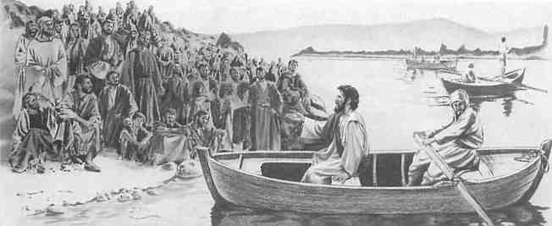

However, contending that since the Trinity is such a confusing mystery, it must have come from divine revelation creates another major problem. Why? Because divine revelation itself does not allow for such a view of God: "God is not a God of confusion."—1 Corinthians 14:33, Revised Standard Version {RS).
In view of that statement, would God be responsible for a doctrine about himself that is so confusing that even Hebrew, Greek, and Latin scholars cannot really explain it?
Furthermore, do people have to be theolo-
gians 'to know the only true God and Jesus Christ whom he has sent'? (John 17:3, JB) If that were the case, why did so few of the educated Jewish religious leaders recognize Jesus as the Messiah? His faithful disciples were, instead, humble farmers, fishermen, tax collectors, housewives. Those common people were so certain of what Jesus taught about God that they could teach it to others and were even willing to die for their belief.—Matthew 15:1-9; 21:23-32, 43; 23:13-36; John 7:45-49; Acts 4:13.

Is It Clearly a Bible Teaching?

IF THE Trinity were true, it should be clearly and consistently presented in the Bible . Why? Because, as the apostles affirmed, the Bible is God's revelation of himself to mankind. And since we need to know God to worship him acceptably, the Bible should be clear in telling us just who he is.
First-century believers accepted the Scriptures as the authentic revelation of God. It was the basis for their beliefs, the final authority. For example, when the apostle Paul preached to people in the city of Beroea, "they received the word with the greatest eagerness of mind, carefully examining the Scriptures daily as to whether these things were so."—Acts 17: 10, 11.
What did prominent men of God at that time use as their authority? Acts 17:2, 3 tells us: "According to Paul's custom ... he reasoned with them from the Scriptures, explaining and proving by references [from the Scriptures]."
Jesus himself set the example in using the Scriptures as the basis for his teaching, repeatedly saying: "It is written." "He interpreted to them things pertaining to himself in all the Scriptures."—Matthew 4:4, 7; Luke 24:27.
Thus Jesus, Paul, and first-century believers used the Scriptures as the foundation for their teaching. They knew that "all Scripture is inspired of God and beneficial for teaching, for reproving, for setting things straight, for disciplining in righteousness, that the man of God
may be fully competent, completely equipped for every good work."—2 Timothy 3:16, 17; see also 1 Corinthians 4:6; 1 Thessalonians 2:13; 2 Peter 1:20, 21.
Since the Bible can 'set things straight/ it should clearly reveal information about a matter as fundamental as the Trinity is claimed to be. But do theologians and historians themselves say that it is clearly a Bible teaching?
"Trinity" in the Bible?
A PROTESTANT publication states: "The word Trinity is not found in the Bible ... It did not find a place formally in the theology of the church till the 4th century." (The Illustrated Bible Dictionary) And a Catholic authority says that the Trinity "is not. . . directly and immediately [the] word of God."—New Catholic Encyclopedia.
The Catholic Encyclopedia also comments: "In Scripture there is as yet no single term by which the Three Divine Persons are denoted together. The word xplac, [tri'as] (of which the Latin trinitas is a translation) is first found in Theophilus of Antioch about A. D. 180. . . . Shortly afterwards it appears in its Latin form of trinitas in Tertullian."
However, this is no proof in itself that Tertullian taught the Trinity. The Catholic work Trinitas—A Theological Encyclopedia of the Holy Trinity, for example, notes that some of Ter-tullian's words were later used by others to

SHOULD YOU BELIEVE IN THE TRINITY?
5

describe the Trinity. Then it cautions: "But hasty conclusions cannot be drawn from usage, for he does not apply the words to Trinitarian theology-"
Testimony of the Hebrew Scriptures
HILE the word "Trinity" is not found in the Bible, is at least the idea of the Trinity taught clearly in it? For instance, what do the Hebrew Scriptures ("Old Testament") reveal?
The Encyclopedia of Religion admits: "Theologians today are in agreement that the Hebrew Bible does not contain a doctrine of the Trinity." And the New Catholic Encyclopedia also says: "The doctrine of the Holy Trinity is not taught in the 0[ld] T[estament]."
Similarly, in his book The Triune God, Jesuit Edmund Fortman admits: "The Old Testament . . . tells us nothing explicitly or by necessary implication of a Triune God who is Father, Son and Holy Spirit. . . . There is no evidence that any sacred writer even suspected the existence of a [ Trinity] within the Godhead. . . . Even to see in [the "Old Testament"] suggestions or fore-shadowings or 'veiled signs' of the trinity of persons, is to go beyond the words and intent of the sacred writers."—Italics ours.
An examination of the Hebrew Scriptures themselves will bear out these comments. Thus, there is no clear teaching of a Trinity in the first 39 books of the Bible that make up the true canon of the inspired Hebrew Scriptures.
Testimony of the Greek Scriptures
ELL, then, do the Christian Greek Scriptures ("New Testament") speak clearly of a Trinity?
The Encyclopedia of Religion says: "Theologians agree that the New Testament also does not contain an explicit doctrine of the Trinity."
Jesuit Fortman states: "The New Testament writers . . . give us no formal or formulated doctrine of the Trinity, no explicit teaching that in one God there are three co-equal divine persons. . . . Nowhere do we find any trinitarian doctrine of three distinct subjects of divine life and activity in the same Godhead."
The New Encyclopaedia Britannica observes: "Neither the word Trinity ● nor the explicit doctrine ● appears in the New Testament."
Bemhard Lohse says in A Short History of Christian Doctrine: "As far as the New Testament is concerned, one does not find in it an actual doctrine of the Trinity."
The New International Dictionary of New Testament Theology similarly states: "The N[ew] T[estament] does not contain the developed doctrine of the Trinity. 'The Bible lacks the express declaration that the Father, the Son, and the Holy Spirit are of equal essence' [said Protestant theologian Karl Barth]."
Yale University professor E. Washburn Hopkins affirmed: "To Jesus and Paul the doctrine of the trinity was apparently unknown; . . . they say nothing about it."—Origin and Evolution of Religion.
Historian Arthur Weigall notes: "Jesus Christ never mentioned such a phenomenon, and nowhere in the New Testament does the word 'Trinity' appear. The idea was only adopted by the Church three hundred years after the death of our Lord."—The Paganism in Our Christianity.
Thus, neither the 39 books of the Hebrew Scriptures nor the canon of 27 inspired books of the Christian Greek Scriptures provide any clear teaching of the Trinity.
Taught by Early Christians?
DID the early Christians teach the Trinity? Note the following comments by historians and theologians:
"Primitive Christianity did not have an explicit doctrine of the Trinity such as was subsequently elaborated in the creeds."—The New International Dictionary of New Testament Theology.
"The early Christians, however, did not at first think of applying the [Trinity] idea to their own faith. They paid their devotions to God the Father and to Jesus Christ, the Son of God, and they recognised the . . . Holy Spirit; but there was no thought of these three being an actual Trinity, co-equal and united in One."—The Paganism in Our Christianity.
"At first the Christian faith was not Trinitarian ... It was not so in the apostolic and sub-apostolic ages, as reflected in the N[ew]

6
SHOULD YOU BELIEVE IN THE TRINITY?

T[estamenrior to God and "never did anything except what the Creator . . . willed him to do and say."
"There is no evidence that any sacred writer even suspected the existence of a [Trinity] within the Godhead."—The Triune God
Irenaeus, who died about 200 C.E., said that the prehuman Jesus had a separate existence from God and was inferior to him. He showed that Jesus is not equal to the "One true and only God," who is "supreme over all, and besides whom there is no other."
Clement of Alexandria, who died about 215 C.E., called God "the uncreated and imperishable and only true God." He said that the Son "is next to the only omnipotent Father" but not equal to him.
Tertullian, who died about 230 C.E., taughtt] and other early Christian writings."—Encyclopaedia of Religion and Ethics.
"The formulation 'one God in three Persons' was not solidly established, certainly not fully assimilated into Christian life and its profession of faith, prior to the end of the 4th century. . . . Among the Apostolic Fathers, there had been nothing even remotely approaching such a mentality or perspective."—New Catholic Encyclopedia.
What the Ante-Nicene Fathers Taught
THE ante-Nicene Fathers were acknowledged to have been leading religious teachers in the early centuries after Christ's birth. What they taught is of interest.
Justin Martyr, who died about 165 C.E., called the prehuman Jesus a created angel who is "other than the God who made all things." He said that Jesus was inferior to God and "never did anything ex
cept what the Creator . . . willed him to do and say."
Irenaeus, who died about 200 C.E., said that the prehuman Jesus had a separate existence from God and was inferior to him. He showed that Jesus is not equal to the "One true and only God," who is "supreme over all, and besides whom there is no other."
Clement of Alexandria, who died about
215 C.E., called God "the uncreated and imper
ishable and only true God." He said that the Son
"is next to the only omnipotent Father" but not
equal to him.

Tertullian, who died about 230 C.E., taught the supremacy of God. He observed: “The Father is different from the Son (another), as he is greater, as he who begets is different from him who begotten, he who sends, different from him who is sent.” He also said:” “There was a time when the Son was not… Before all things God was alone.”

Hippolytus, who died about 235 C.E., said that God is "the one God, the first and the only One, the Maker and Lord of all," who "had nothing co-eval [of equal age] with him . . . But he was One, alone by himself; who, willing it, called into being what had no being before," such as the created prehuman Jesus.
Origen, who died about 250 C.E., said that
"the Father and Son are two substances . . . two
things as to their essence," and that "compared
with the Father, [the Son] is a
very small light."
Summing up the historical evidence, Alvan Lamson says in The Church of the First Three Centuries: "The modern popular doctrine of the Trinity .. . derives no support from the language of Justin [Martyr]: and this observation may be extended to all the ante-Nicene Fathers; that is, to all Christian writers for three centuries after the birth of Christ. It is true, they speak of the Father, Son, and . . . holy Spirit, but not as co-equal, not as one numerical essence, not as Three in One, in any sense now admitted by Trinitarians. The very reverse is the fact."
Thus, the testimony of the Bible and of history makes clear that the Trinity was unknown throughout Biblical times and for several centuries thereafter.

How Did the Trinity Doctrine Develop? ● ●

AT THIS point you might ask: 'If the Trinity is not a Biblical teaching, how did it become a doctrine of Christendom?' Many think that it was formulated at the Council of Nicaea in 325 C.E.
That is not totally correct, however. The
Council of Nicaea did assert that Christ was of the same substance as God, which laid the groundwork for later Trinitarian theology. But it did not establish the Trinity, for at that council there was no mention of the holy spirit as the third person of a triune Godhead.

SHOULD YOU BELIEVE IN THE TRINITY?

"Constantine had basically no understanding whatsoever of the questions that were being asked in Greek theology."—A Short History of Christian Doctrine
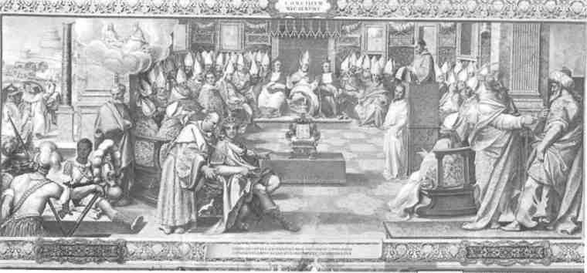

Constantino's Role at Nicaea
'Fourth century Trinitarian-ism was a deviation from early Christian teaching.' —The Encyclopedia Americana
FOR many years, there had been much opposition on Biblical grounds to the developing idea that Jesus was God. To try to solve the dispute, Roman emperor Constan-tine summoned all bishops to Nicaea. About 300, a fraction of the total, actually attended.
Constantine was not a Christian●. Supposedly, he converted later in life, but he was not baptized until he lay dying. Regarding him, Henry Chadwick says in The Early Church: "Constantine, like his father, worshipped the Unconquered Sun; . . . his conversion should not be interpreted as an inward experience of grace ... It was a military matter. His comprehension of Christian doctrine was never very clear, but he was sure that victory in battle lay in the gift of the God of the Christians."
What role did this unbaptized emperor play at the Council of Nicaea? The Encyclopsedia Britannica relates: "Constantine himself presided, actively guiding the discussions, and personally proposed . . . the crucial formula expressing the relation of Christ to God in the creed issued by the council, 'of one substance with the Father' . . . Overawed by the emperor, the bishops, with two exceptions only, signed the creed, many of them much against their inclination."
Hence, Constantine's role was crucial. After two months of furious religious debate, this pagan politician intervened and decided in favor of those who said that Jesus was God. But why? Certainly not because of any Biblical
conviction. "Constantine had basically no understanding whatsoever of the questions that were being asked in Greek theology," says A Short History of Christian Doctrine. What he did understand was that religious division was a threat to his empire, and he wanted to solidify his domain.
None of the bishops at Nicaea promoted a Trinity, however. They decided only the nature of Jesus but not the role of the holy spirit. If a Trinity had been a clear Bible truth, should they not have proposed it at that time?
Further Development
AFTER Nicaea, debates on the subject continued for decades. Those who believed that Jesus was not equal to God even came back into favor for a time. But later Emperor Theodosius decided against them. He established the creed of the Council of Nicaea as the standard for his realm and convened the Council of Constantinople in 381 C.E. to clarify the formula.
That council agreed to place the holy spirit on the same level as God and Christ. For the first time, Christendom's Trinity began to come into focus.
Yet, even after the Council of Constantinople, the Trinity did not become a widely accepted creed. Many opposed it and thus brought on themselves violent persecution. It was only in later centuries that the Trinity was formulated into set creeds. The Encyclopedia Americana notes: "The full development

8
SHOULD YOU BELIEVE IN THE TRINITY?

of Trinitarianism took place in the West, in the Scholasticism of the Middle Ages, when an explanation was undertaken in terms of philosophy and psychology."
The Athanasian Creed
THE Trinity was denned more fully in the Athanasian Creed. Athanasius was a clergyman who supported Constantine at Nicaea. The creed that bears his name declares: "We worship one God in Trinity . . . The Father is God, the Son is God, and the Holy Ghost is God; and yet they are not three gods, but one God."
Well-informed scholars agree, however, that Athanasius did not compose this creed. The New Encyclopaedia Britannica comments: "The creed was unknown to the Eastern Church until the 12th century. Since the 17th century, scholars have generally agreed that the Athanasian Creed was not written byAthanasius(died373)butwas probably composed in southern France during the 5th century. . . . The creed's influence seems to have been primarily in southern France and Spain in the 6th and 7th centuries. It was used in the liturgy of the church in Germany in the 9th century and somewhat later in Rome."
So it took centuries from the time of Christ for the Trinity to become widely accepted in Christendom. And in all of this, what guided the decisions? Was it the Word of God, or was it clerical and political considerations? In Origin and Evolution of Religion, E. W. Hopkins answers: "The final orthodox definition of the trinity was largely a matter of church politics."
Apostasy Foretold
THIS disreputable history of the Trinity fits in with what Jesus and his apostles foretold would follow their time. They said that there would be an apostasy, a deviation, a falling away from true worship until Christ's return, when true worship would be restored before God's day of destruction of this system of things.
Regarding that "day," the apostle Paul said: "It will not come unless the apostasy comes
'The Triad of the Great Gods"
Many centuries before the time of Christ, there were triads, or trinities, of gods in ancient Babylonia and Assyria. The French "Larousse Encyclopedia of Mythology" notes one such triad in that Mesopotamian area: "The universe was divided into three regions each of which became the domain of a god. Anu's share was the sky. The earth was given to Enlil. Ea became the ruler of the waters. Together they constituted the triad of the Great Gods."
first and the man of lawlessness gets revealed." (2 Thessalonians 2:3, 7) Later, he foretold: "When I have gone fierce wolves will invade you and will have no mercy on the flock. Even from your own ranks there will be men coming forward with a travesty of the truth on their lips to induce the disciples to follow them." (Acts 20:29, 30, JB) Other disciples of Jesus also wrote of this apostasy with its 'lawless' clergy class.—See, for example, 2 Peter 2:1; 1 John 4:1-3; Jude 3, 4.
Paul also wrote: "The time is sure to come when, far from being content with sound teaching, people will be avid for the latest novelty and collect themselves a whole series of teachers according to their own tastes; and then, instead of listening to the truth, they will turn to myths."—2 Timothy 4:3, 4, JB.
Jesus himself explained what was behind this falling away from true worship. He said that he had sowed good seeds but that the enemy, Satan, would oversow the field with weeds. So along with the first blades of wheat, the weeds appeared also. Thus, a deviation from pure Christianity was to be expected until the harvest, when Christ would set matters right. (Matthew 13:24-43) The Encyclopedia Americana comments: "Fourth century Trinitarianism did not reflect accurately early Christian teaching regarding the nature of God; it was, on the contrary, a deviation from this teaching." Where, then, did this deviation originate?—1 Timothy 1:6.

SHOULD YOU BELIEVE IN THE TRINITY?
9

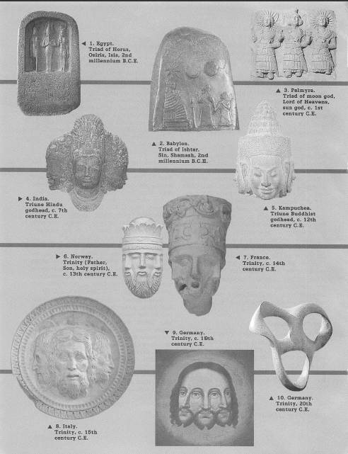

What Influenced It ●
THROUGHOUT the ancient world, as far back _L as Babylonia, the worship of pagan gods grouped in threes, or triads, was common. That influence was also prevalent in Egypt, Greece, and Rome in the centuries before, during, and after Christ. And after the death of the apostles, such pagan beliefs began to invade Christianity.
Historian Will Durant observed: "Christianity did not destroy paganism; it adopted it. .. . From Egypt came the ideas of a divine trinity." And in the book Egyptian Religion, Siegfried Morenz notes: "The trinity was a major preoccupation of Egyptian theologians . . . Three gods are combined and treated as a single being, addressed in the singular. In this way the spiritual force of Egyptian religion shows a direct link with Christian theology."
Thus, in Alexandria, Egypt, churchmen of the late third and early fourth centuries, such as Athanasius, reflected this influence as they formulated ideas that led to the Trinity. Their own influence spread, so that Morenz considers "Alexandrian theology as the intermediary between the Egyptian religious heritage and Christianity."
In the preface to Edward Gibbon's History of Christianity, we read: "If Paganism was conquered by Christianity, it is equally true that Christianity was corrupted by Paganism. The pure Deism of the first Christians . . . was changed, by the Church of Rome, into the incomprehensible dogma of the trinity. Many of the pagan tenets, invented by the Egyptians and idealized by Plato, were retained as being worthy of belief."
A Dictionary of Religious Knowledge notes that many say that the Trinity "is a corruption borrowed from the heathen religions, and ingrafted on the Christian faith." And The Paganism in Our Christianity declares: "The origin of the [Trinity] is entirely pagan."
That is why, in the Encyclopaedia of Religion and Ethics, James Hastings wrote: "In Indian religion, e.g., we meet with the trinitarian group of Brahma, Siva, and Visnu; and in Egyptian religion with the trinitarian group of Osiris, Isis, and Horus . . . Nor is it only in historical religions that we find God viewed as a Trinity. One recalls in particular the Neo-Platonic view of the Supreme or Ultimate Reality," which is "triadically repre-
sented." What does the Greek philosopher Plato have to do with the Trinity?
Platonism
PLATO, it is thought, lived from 428 to 347 before Christ. While he did not teach the Trinity in its present form, his philosophies paved the way for it. Later, philosophical movements that included triadic beliefs sprang up, and these were influenced by Plato's ideas of God and nature.
The French Nouveau Dictionnaire Universel (New Universal Dictionary) says of Plato's influence: "The Platonic trinity, itself merely a rearrangement of older trinities dating back to earlier peoples, appears to be the rational philosophic trinity of attributes that gave birth to the three hypostases or divine persons taught by the Christian churches. . . . This Greek philosopher's conception of the divine trinity... can be found in all the ancient [pagan] religions."
The New Schaff-Herzog Encyclopedia of Religious Knowledge shows the influence of this Greek philosophy: "The doctrines of the Logos and the Trinity received their shape from Greek Fathers, who . . . were much influenced, directly or indirectly, by the Platonic philosophy .. . That errors and corruptions crept into the Church from this source can not be denied."
The Church of the First Three Centuries says: "The doctrine of the Trinity was of gradual and comparatively late formation; ... it had its origin in a source entirely foreign from that of the Jewish and Christian Scriptures; ... it grew up, and was ingrafted on Christianity, through the hands of the Platonizing Fathers."
By the end of the third century C.E., "Christianity" and the new Platonic philosophies became inseparably united. As Adolf Harnack states in Outlines of the History of Dogma, church doctrine became "firmly rooted in the soil of Hellenism [pagan Greek thought]. Thereby it became a mystery to the great majority of Christians."
The church claimed that its new doctrines were based on the Bible. But Harnack says: "In reality it legitimized in its midst the Hellenic speculation, the superstitious views and customs of pagan mystery-worship."
In the book A Statement of Reasons, Andrews Norton says of the Trinity: "We can

SHOULD YOU BELIEVE IN THE TRINITY?
11

Hindu Trinity
The book "The Symbolism of Hindu Gods and Rituals" says regarding a Hindu trinity that existed centuries before Christ: "Siva is one of the gods of the Trinity. He is said to be the god of destruction. The other two gods are Brahma, the god of creation and Vishnu, the god of maintenance.... To indicate that these three processes are one and the same the three gods are combined in one form."—Published by A. Parthasarathy, Bombay.
trace the history of this doctrine, and discover its source, not in the Christian revelation, but in the Platonic philosophy . . . The Trinity is not a doctrine of Christ and his Apostles, but a fiction of the school of the later Platonists."
Thus, in the fourth century C.E., the apostasy foretold by Jesus and the apostles came into full bloom. Development of the Trinity was just one evidence of this. The apostate churches also began embracing other pagan ideas, such as hellfire, immortality of the soul, and
idolatry. Spiritually speaking, Christendom had entered its foretold dark ages, dominated by a growing "man of lawlessness" clergy class.—2 Thessalonians 2:3, 7.
Why Did God's Prophets Not Teach It?
HY, for thousands of years, did none of God's prophets teach his people about the Trinity? At the latest, would Jesus not use his ability as the Great Teacher to make the Trinity clear to his followers? Would God inspire hundreds of pages of Scripture and yet not use any of this instruction to teach the Trinity if it were the "central doctrine" of faith?
Are Christians to believe that centuries after Christ and after having inspired the writing of the Bible, God would back the formulation of a doctrine that was unknown to his servants for thousands of years, one that is an "inscrutable mystery" "beyond the grasp of human reason," one that admittedly had a pagan background and was "largely a matter of church politics"?
The testimony of history is clear: The Trinity teaching is a deviation from the truth, an apostatizing from it.

What Does the Bible
Say About God and Jesus?

IF PEOPLE were to read the Bible from cover to cover without any preconceived idea of a Trinity, would they arrive at such a concept on their own? Not at all.
What comes through very clearly to an impartial reader is that God alone is the Almighty, the Creator, separate and distinct from anyone else, and that Jesus, even in his prehuman existence, is also separate and distinct, a created being, subordinate to God.
God Is One, Not Three
THE Bible teaching that God is one is called monotheism . And L. L. Paine, professor of ecclesiastical history, indicates that monothe-
12
ism in its purest form does not allow for a Trinity: "The Old Testament is strictly monotheistic. God is a single personal being. The idea that a trinity is to be found there ... is utterly without foundation."
Was there any change from monotheism after Jesus came to the earth? Paine answers: "On this point there is no break between the Old Testament and the New. The monotheistic tradition is continued. Jesus was a Jew, trained by Jewish parents in the Old Testament scriptures. His teaching was Jewish to the core; a new gospel indeed, but not a new theology. . . . And he accepted as his own belief the great text of Jewish monotheism:
SHOULD YOU BELIEVE IN THE TRINITY?

'Hear, O Israel, the Lord our God is one God.'"
Those words are found at Deuteronomy 6:4. The Catholic New Jerusalem Bible (NJB) here reads: "Listen, Israel: Yahweh our God is the one, the only Yahweh."* In the grammar of that verse, the word "one" has no plural modifiers to suggest that it means anything but one individual.
The Christian apostle Paul did not indicate any change in the nature of God either, even after Jesus came to the earth. He wrote: "God is only one."—Galatians 3:20; see also 1 Corinthians 8:4-6.
Thousands of times throughout the Bible, God is spoken of as one person. When he speaks, it is as one undivided individual. The Bible could not be any clearer on this. As God states: "I am Jehovah. That is my name; and to no one else shall I give my own glory." (Isaiah 42:8) "I am Yahweh your God ... You shall have no gods except me."(Italics ours.)—Exodus 20:2, 3, JB.
Why would all the God-inspired Bible writers speak of God as one person if he were actually three persons? What purpose would that serve, except to mislead people? Surely, if God were composed of three persons, he would have had his Bible writers make it abundantly clear so that there could be no doubt about it. At least the writers of the Christian Greek Scriptures who had personal contact with God's own Son would have done so. But they did not.
Instead, what the Bible writers did make abundantly clear is that God is one Person—a unique, unpartitioned Being who has no equal: "I am Jehovah, and there is no one else. With the exception of me there is no God." (Isaiah 45:5) "You, whose name is Jehovah, you alone are the Most High over all the earth."—Psalm 83:18.
Not a Plural God
JESUS called God "the only true God." (John 17:3) Never did he refer to God as a deity of plural persons. That is why nowhere in the Bible is anyone but Jehovah called Almighty. Otherwise, it voids the meaning of the word
* God's name is rendered "Yahweh" in some translations, "Jehovah" in others.
SHOULD YOU BELIEVE IN THE TRINITY?
"almighty." Neither Jesus nor the holy spirit is ever called that, for Jehovah alone is supreme. At Genesis 17:1 he declares: "I am God Almighty." And Exodus 18:11 says: "Jehovah is greater than all the other gods."
In the Hebrew Scriptures, the word 'eloh'ah (god) has two plural forms, namely, 'elo-him' (gods) and 'eloheh' (gods of). These plural forms generally refer to Jehovah, in which case they are translated in the singular as "God." Do these plural forms indicate a Trinity? No, they do not. In A Dictionary of the Bible, William Smith says: "The fanciful idea that [ 'elo-him"] referred to the trinity of persons in the Godhead hardly finds now a supporter among scholars. It is either what grammarians call the plural of majesty, or it denotes the fullness of divine strength, the sum of the powers displayed by God."
The American Journal of Semitic Languages and Literatures says of 'elo-him": "It is almost invariably construed with a singular verbal predicate, and takes a singular adjectival attribute." To illustrate this, the title 'eJo-him' appears 35 times by itself in the account of creation, and every time the verb describing what God said and did is singular. (Genesis 1:1-2:4) Thus, that publication concludes: "[ 'Elo-him'] must rather be explained as an intensive plural, denoting greatness and majesty."
'Elo-him' means, not "persons," but "gods." So those who argue that this word implies a Trinity make themselves polytheists, worshipers of more than one God. Why? Because it would mean that there were three gods in the Trinity. But nearly all Trinity supporters reject the view that the Trinity is made up of three separate gods.
The Bible also uses the words 'elo-him' and 'elo-heh' when referring to a number of false idol gods. (Exodus 12:12; 20:23) But at other times it may refer to just a single false god, as when the Philistines referred to "Dagon their god ['eloheh']." (Judges 16:23, 24) Baal is called "a god ['elo-him']." (1 Kings 18:27) In addition, the term is used for humans. (Psalm 82:1, 6) Moses was told that he was to serve as "God" ['elo-him'] to Aaron and to Pharaoh. —Exodus 4:16; 7:1.
13

Obviously, using the titles 'elo-him' and 'eJo-jhah'for false gods, and even humans, did not imply that each was a plurality of gods; neither does applying 'elo-him' or 'eloheh' to Jehovah mean that he is more than one person, especially when we consider the testimony of the rest of the Bible on this subject.
Having been created by
God, Jesus is in a secondary
position in time, power,
and knowledge
Jesus a Separate Creation
WHILE on earth, Jesus was a human, although a perfect one because it was God who transferred the life-force of Jesus to the womb of Mary. (Matthew 1:18-25) But that is not how he began. He himself declared that he had "descended from heaven." (John 3:13) So it was only natural that he would later say to his followers: "What if you should see the Son of man [Jesus] ascend to where he was before?"—John 6:62, NJB.
Thus, Jesus had an existence in heaven before coming to the earth. But was it as one of the persons in an almighty, eternal triune Godhead? No, for the Bible plainly states that in his prehuman existence, Jesus was a created spirit being, just as angels were spirit beings created by God. Neither the angels nor Jesus had existed before their creation.
Jesus, in his prehuman existence, was "the first-born of all creation." (Colossians 1:15, NJB) He was "the beginning of God's creation." (Revelation 3:14, RS, Catholic edition). "Beginning" [Greek, arkhe'] cannot rightly be interpreted to mean that Jesus was the 'beginner' of God's creation. In his Bible writings, John uses various forms of the Greek word arkhe' more than 20 times, and these always have the common meaning of "beginning." Yes, Jesus was created by God as the beginning of God's invisible creations.Notice how closely those references to the origin of Jesus correlate with expressions uttered by the figurative "Wisdom" in the Bible book of Proverbs: "Yahweh created me, first-fruits of his fashioning, before the oldest of his works. Before the mountains were settled, before the hills, I came to birth; before he had
14
made the earth, the countryside, and the first elements of the world." (Proverbs 8:12, 22, 25, 26, NJB) While the term "Wisdom" is used to personify the one whom God created, most scholars agree that it is actually a figure of speech for Jesus as a spirit creature prior to his human existence.
As "Wisdom" in his prehuman existence, Jesus goes on to say that he was "by his [God's] side, a master craftsman." (Proverbs 8: 30, JB) In harmony with this role as master craftsman, Colossians 1:16 says of Jesus that "through him God created everything in heaven and on earth."—Today's English Version {TEV).
So it was by means of this master worker, his junior partner, as it were, that Almighty God created all other things. The Bible summarizes the matter this way: "For us there is one God, the Father, from whom are all things . . . and one Lord, Jesus Christ, through whom are all things." (Italics ours.)—1 Corinthians 8:6, RS, Catholic edition.
It no doubt was to this master craftsman that God said: "Let us make man in our image." (Genesis 1:26) Some have claimed that the "us" and "our" in this expression indicate a Trinity. But if you were to say, 'Let us make something for ourselves,' no one would normally understand this to imply that several persons are combined as one inside of you. You simply mean that two or more individuals will work together on something. So, too, when God used "us" and "our," he was simply addressing another individual, his first spirit creation, the master craftsman, the prehuman Jesus.
Could God Be Tempted?
AT MATTHEW 4:1, Jesus is spoken of as being "tempted by the Devil." After showing Jesus "all the kingdoms of the world and their glory," Satan said: "All these things I will give you if you fall down and do an act of worship to me." (Matthew 4:8, 9) Satan was trying to cause Jesus to be disloyal to God.
But what test of loyalty would that be if Jesus were God? Could God rebel against himself? No,
SHOULD YOU BELIEVE IN THE TRINITY?
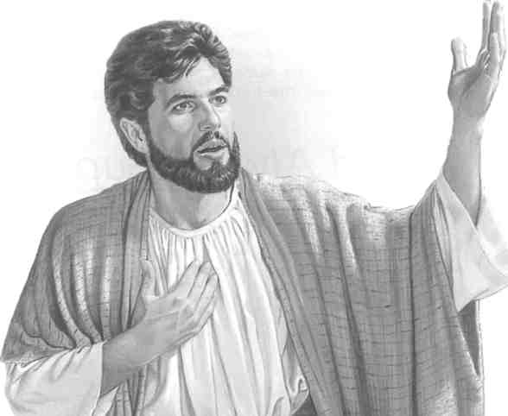
but angels and humans could rebel against God and did. The temptation of Jesus would make sense only if he was, not God, but a separate individual who had his own free will, one who could have been disloyal had he chosen to be, such as an angel or a human.
On the other hand, it is unimaginable that God could sin and be disloyal to himself. "Perfect is his activity ... A God of faithfulness, . . . righteous and upright is he." (Deuteronomy 32:4) So if Jesus had been God, he could not have been tempted.—James 1:13.
Not being God, Jesus could have been disloyal. But he remained faithful, saying: "Go away, Satan! For it is written, 'It is Jehovah your God you must worship, and it is to him alone you must render sacred service.'"—Matthew 4:10.
How Much Was the Ransom?
ONE of the main reasons why Jesus came to earth also has a direct bearing on the Trinity. The Bible states: "There is one God, and one mediator between God and men, a man, Christ Jesus, who gave himself a corresponding ransom for all."—1 Timothy 2:5, 6.
Jesus, no more and no less than a perfect human, became a ransom that compensated exactly for what Adam lost—the right to perfect human life on earth. So Jesus could rightly be called "the last Adam" by the apostle Paul, who said in the same context: "Just as in Adam all are dying, so also in the Christ all will be made alive." (1 Corinthians 15:22, 45) The perfect human life of Jesus was the "corresponding ransom" required by divine justice —no more, no less. A basic principle even of human justice is that the price paid should fit the wrong committed.
If Jesus, however, were part of a Godhead, the ransom price would have been infinitely higher than what God's own Law required. (Exodus 21:23-25; Leviticus 24:19-21) It was only a perfect human, Adam, who sinned in
Jesus said that he had a prehuman existence, having been created by God as the beginning of God's invisible creations
Eden, not God. So the ransom, to be truly in line with God's justice, had to be strictly an equivalent—a perfect human, "the last Adam." Thus, when God sent Jesus to earth as the ransom, he made Jesus to be what would satisfy justice, not an incarnation, not a god-man, but a perfect man, "lower than angels." (Hebrews 2:9; compare Psalm 8:5, 6.) How could any part of an almighty Godhead—Father, Son, or holy spirit—ever be lower than angels?
How the "Only-Begotten Son"?
THE Bible calls Jesus the "only-begotten Son" of God. (John 1:14; 3:16, 18; 1 John 4:9) Trinitarians say that since God is eternal, so the Son of God is eternal. But how can a person be a son and at the same time be as old as his father?
Trinitarians claim that in the case of Jesus, "only-begotten" is not the same as the dictionary definition of "begetting," which is "to procreate as the father." (Webster's Ninth New Collegiate Dictionary) They say that in Jesus' case it means "the sense of unoriginated relationship," a sort of only son relationship without the begetting. (Vine's Expository Dictionary of Old and New Testament Words) Does that sound logical to you? Can a man father a son without begetting him?
Furthermore, why does the Bible use the very same Greek word for "only-begotten" (as Vine admits without any explanation) to describe the

relationship of Isaac to Abraham? Hebrews 11: 17 speaks of Isaac as Abraham's "only-begotten son." There can be no question that in Isaac's case, he was only-begotten in the normal sense, not equal in time or position to his father.
The basic Greek word for "only-begotten" used for Jesus and Isaac is mo-no-ge-nes', from mo'nos, meaning "only," and gi'nomai, a root word meaning "to generate," "to become (come into being)," states Strong's Exhaustive Concordance. Hence, mo-no-ge-nes' is defined as: "Only born, only begotten, i.e. an only child." —A Greek and English Lexicon of the New Testament, by E. Robinson.
The Theological Dictionary of the New Testament, edited by Gerhard Kittel, says: "[Mono-genes'] means 'of sole descent,' i.e., without brothers or sisters." This book also states that at John 1:18; 3:16, 18; and 1 John 4:9, "the relation of Jesus is not just compared to that of an only child to its father. It is the relation of the only-begotten to the Father."
So Jesus, the only-begotten Son, had a beginning to his life. And Almighty God can rightly be called his Begetter, or Father, in the same sense that an earthly father, like Abraham, begets a son. (Hebrews 11:17) Hence, when the Bible speaks of God as the "Father" of Jesus, it means what it says—that they are two separate individuals. God is the senior. Jesus is the junior—in time, position, power, and knowledge.
When one considers that Jesus was not the only spirit son of God created in heaven, it becomes evident why the term "only-begotten Son" was used in his case. Countless other created spirit beings, angels, are also called "sons of God," in the same sense that Adam was, because their life-force originated with
Jehovah God, the Fountain, or Source, of life. (Job 38:7; Psalm 36:9; Luke 3:38) But these were all created through the "only-begotten Son," who was the only one directly begotten by God.—Colossians 1:15-17.
Was Jesus Considered to Be God?
WHILE Jesus is often called the Son of God in the Bible, nobody in the first century ever thought of him as being God the Son. Even the demons, who "believe there is one God," knew from their experience in the spirit realm that Jesus was not God. So, correctly, they addressed Jesus as the separate "Son of God." (James 2:19; Matthew 8:29) And when Jesus died, the pagan Roman soldiers standing by knew enough to say that what they had heard from his followers must be right, not that Jesus was God, but that "certainly this was God's Son."—Matthew 27:54.
Hence, the phrase "Son of God" refers to Jesus as a separate created being, not as part of a Trinity. As the Son of God, he could not be God himself, for John 1:18 says: "No one has ever seen God."—RS, Catholic edition.
The disciples viewed Jesus as the "one mediator between God and men," not as God himself. (1 Timothy 2:5) Since by definition a mediator is someone separate from those who need mediation, it would be a contradiction for Jesus to be one entity with either of the parties he is trying to reconcile. That would be a pretending to be something he is not.
The Bible is clear and consistent about the relationship of God to Jesus. Jehovah God alone is Almighty. He created the prehuman Jesus directly. Thus, Jesus had a beginning and could never be coequal with God in power or eternity.

Is God Always Superior to Jesus?

JESUS never claimed to be God. Everything he said about himself indicates that he did not consider himself equal to God in any way—not in power, not in knowledge, not in age.
16
In every period of his existence, whether in heaven or on earth, his speech and conduct reflect subordination to God. God is always the superior, Jesus the lesser one who was created by God.
SHOULD YOU BELIEVE IN THE TRINITY?

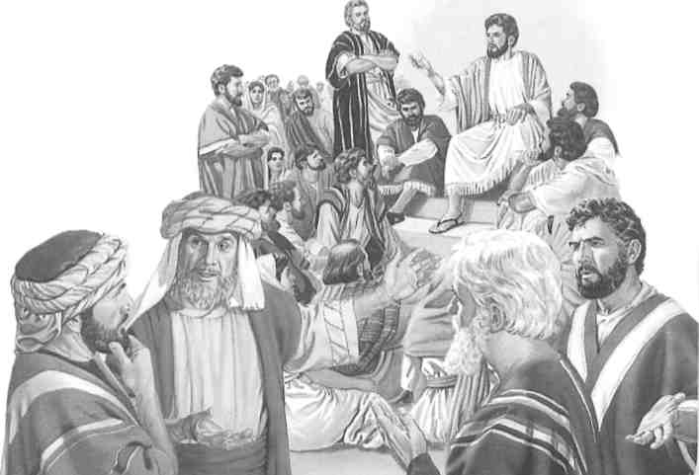
Jesus Distinguished From God
TIME and again, Jesus showed that he was a creature separate from God and that he, Jesus, had a God above him, a God whom he worshiped, a God whom he called "Father." In prayer to God, that is, the Father, Jesus said, "You, the only true God." (John 17:3) At John 20:17 he said to Mary Magdalene: "I am ascending to my Father and your Father, to my God and your God." (RS, Catholic edition) At 2 Corinthians 1:3 the apostle Paul confirms this relationship: "Blessed be the God and Father of our Lord Jesus Christ." Since Jesus had a God, his Father, he could not at the same time be that God.
The apostle Paul had no reservations about speaking of Jesus and God as distinctly separate: "For us there is one God, the Father, . . . and there is one Lord, Jesus Christ." (1 Corinthians 8:6, JB) The apostle shows the distinction when he mentions "the presence of God and of Christ Jesus and of the elect angels." (1 Timothy 5:21, RS Common Bible) Just as Paul speaks of Jesus and the angels as being distinct from one another in heaven, so too are Jesus and God.
Jesus' words at John 8:17, 18 are also significant. He states: "In your own Law it is written, 'The witness of two men is true.' I am one that bears witness about myself, and the Father who sent me bears witness about me." Here Jesus shows that he and the Father, that is. Almighty God, must be two distinct entities, for how else could there truly be two witnesses?
Jesus further showed that he was a separate being from God by saying: "Why do you call me good? No one is good but God alone." (Mark 10:18, JB) So Jesus was saying that no one is as good as God is, not even Jesus himself. God is good in a way that separates him from Jesus.
Jesus told the Jews: "I have come down from heaven to do, not my will, but the will of him that sent me."—John 6:38
God's Submissive Servant
TIME and again, Jesus made statements such as: "The Son cannot do anything at his own pleasure, he can only do what he sees his Father doing." (John 5:19, The Holy Bible, by Monsignor R. A. Knox) "I have come down from heaven to do, not my will, but the will of him that sent me." (John 6:38) "What I teach is not mine, but belongs to him that sent me." (John 7:16) Is not the sender superior to the one sent?
This relationship is evident in Jesus' illustration of the vineyard. He likened God, his Father, to the owner of the vineyard, who traveled abroad and left it in the charge of cultivators, who represented the Jewish clergy. When the owner later sent a slave to get some of the fruit of the vineyard, the cultivators beat the slave and sent him away empty-handed. Then the owner sent a second slave, and later a third, both of whom got the same treatment. Finally, the owner said: "I will send my son [Jesus] the beloved. Likely they will respect this one." But the corrupt cultivators said: "This is the heir; let us kill him, that the inheritance may become ours.' With that they threw him outside the vineyard and killed him." (Luke 20:9-16) Thus Jesus illustrated his own position as one being sent by God to do God's will, just as a father sends a submissive son.
The followers of Jesus always viewed him as a submissive servant of God, not as God's
equal. They prayed to God about "thy holy servant Jesus, whom thou didst anoint, . . . and signs and wonders are performed through the name of thy holy servant Jesus."—Acts 4:23, 27, 30, RS, Catholic edition.
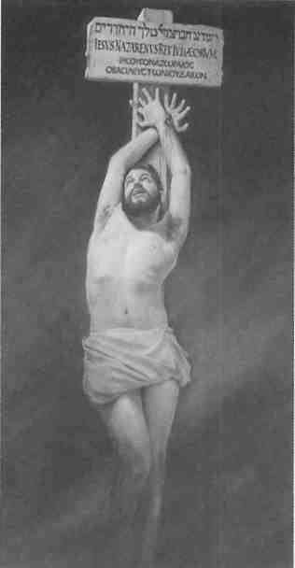
God Superior at All Times
AT THE very outset of Jesus' ministry, when he came up out of the baptismal water, God's voice from heaven said: "This is my Son, the beloved, whom I have approved." (Matthew 3:16, 17) Was God saying that he was his own son, that he approved himself, that he sent himself? No, God the Creator was saying that he, as the superior, was approving a lesser one, his Son Jesus, for the work ahead.
Jesus indicated his Father's superiority when he said: "Jehovah's spirit is upon me, because he anointed me to declare good news to the poor." (Luke 4:18) Anointing is the giving of authority or a commission by a superior to someone who does not already have authority. Here God is plainly the superior, for he anointed Jesus, giving him authority that he did not previously have.
Jesus made his Father's superiority clear when the mother of two disciples asked that her sons sit one at the right and one at the left of Jesus when he came into his Kingdom. Jesus answered: "As for seats at my right hand and my left, these are not mine to grant; they belong to those to whom they have been allotted by my Father," that is, God. (Matthew 20:23, JB) Had Jesus been Almighty God, those positions would have been his to give. But Jesus could not give them, for they were God's to give, and Jesus was not God.
Jesus' own prayers are a powerful example of his inferior position. When Jesus was about to die, he showed who his superior was by praying: "Father, if you wish, remove this cup from
18
me. Nevertheless, let, not my will, but yours take place." (Luke 22:42) To whom was he praying? To a part of himself? No, he was praying to someone entirely separate, his Father, God, whose will was superior and could be different from his own, the only One able to "remove this cup."
Then, as he neared death, Jesus cried out: "My God, my God, why have you deserted me?" (Mark 15:34, JB) To whom was Jesus crying out? To himself or to part of himself? Surely, that cry, "My God," was not from someone who considered himself to be God. And if Jesus were God, then by whom was he deserted? Himself? That would not make sense. Jesus also said: "Father, into your hands I entrust my spirit." (Luke 23:46) If Jesus were God, for what reason should he entrust his spirit to the Father?
After Jesus died, he was in the tomb for parts of three days. If he were God, then Ha-bakkuk 1:12 is wrong when it says: "O my God, my Holy One, you do not die." But the Bible says that Jesus did die and was unconscious in the tomb. And who resurrected Jesus from the dead? If he was truly dead, he could not have resurrected himself. On the other hand, if he was not really dead, his pretended death would not have paid the ransom price for Adam's sin. But he did pay that price in full by his genuine death. So it was "God [who] resurrected [Jesus] by loosing the pangs of death." (Acts 2:24) The superior, God Almighty, raised the lesser, his servant Jesus, from the dead.
Does Jesus' ability to perform miracles, such as resurrecting people, indicate that he was God? Well, the apostles and the prophets Elijah
When Jesus cried out: "My God, my God, why have you deserted me?" he surely did not believe that he himself was God

and Elisha had that power too, but that did not make them more than men. God gave the power to perform miracles to the prophets, Jesus, and the apostles to show that He was backing them. But it did not make any of them part of a plural Godhead.
'New Testament research has been
leading an increasing number of
scholars to the conclusion that
Jesus certainly never believed
himself to be God.'—Bulletin
of the John Rylands Library
Jesus Had limited Knowledge
WHEN Jesus gave his prophecy about the end of this system of things, he stated: "But of that day or that hour no one knows, not even the angels in heaven, nor the Son, but only the Father." (Mark 13:32, RS, Catholic edition) Had Jesus been the equal Son part of a Godhead, he would have known what the Father knows. But Jesus did not know, for he was not equal to God.
Similarly, we read at Hebrews 5:8 that Jesus from the things he suffered." Can we imagine that God had to learn anything? No, but Jesus did, for he did not know everything that God knew. And he had to learn something that God never needs to learn—obedience. God never has to obey anyone.
"learned obedience
The difference between what God knows and what Christ knows also existed when Jesus was resurrected to heaven to be with God. Note the first words of the last book of the Bible: "The revelation of Jesus Christ, which God gave him." (Revelation 1:1, RS, Catholic edition) If Jesus himself were part of a Godhead, would he have to be given a revelation by another part of the Godhead—God? Surely he would have known all about it, for God knew. But Jesus did not know, for he was not God.
Jesus Continues Subordinate
IN HIS prehuman existence, and also when he was on earth, Jesus was subordinate to God. After his resurrection, he continues to be in a subordinate, secondary position.
Speaking of the resurrection of Jesus, Peter and those with him told the Jewish Sanhedrin: "God exalted this one [Jesus] ... to his right hand." (Acts 5:31) Paul said: "God exalted him to a superior position." (Philippians 2:9) If Je-
sus had been God, how could Jesus have been exalted, that is, raised to a higher position than he had previously enjoyed? He would already have been an exalted part of the Trinity. If, before his exaltation, Jesus had been equal to God, exalting him any further would have made him superior to God.
Paul also said that Christ entered "heaven itself, so that he could appear in the actual presence of God on our behalf." (Hebrews 9:24, JB) If you appear in someone else's presence, how can you be that person? You cannot. You must be different and separate.
Similarly, just before being stoned to death, the martyr Stephen "gazed into heaven and caught sight of God's glory and of Jesus standing at God's right hand." (Acts 7:55) Clearly, he saw two separate individuals—but no holy spirit, no Trinity Godhead.
In the account at Revelation 4:8 to 5:7, God is shown seated on his heavenly throne, but Jesus is not. He has to approach God to take a scroll from God's right hand. This shows that in heaven Jesus is not God but is separate from him.
In agreement with the foregoing, the Bulletin of the John Rylands Library in Manchester, England, states: "In his post-resurrection heavenly life, Jesus is portrayed as retaining a personal individuality every bit as distinct and separate from the person of God as was his in his life on earth as the terrestrial Jesus. Alongside God and compared with God, he appears, indeed, as yet another heavenly being in God's heavenly court, just as the angels were —though as God's Son, he stands in a different category, and ranks far above them."—Compare Philippians 2:11.
The Bulletin also says: "What, however, is said of his life and functions as the celestial Christ neither means nor implies that in divine status he stands on a par with God himself and is fully God. On the contrary, in the New Testament picture of his heavenly person and ministry we behold a figure both separate from and subordinate to God."

SHOULD YOU BELIEVE IN THE TRINITY?
19

In the everlasting future in heaven, Jesus will continue to be a separate, subordinate servant of God. The Bible expresses it this way: "After that will come the end, when he [Jesus in heaven] will hand over the kingdom to God the Father . . . Then the Son himself will be subjected to the One who has subjected everything to him, so that God may be all in all." —1 Corinthians 15:24, 28, NJB.
Jesus Never Claimed to Be God
THE Bible's position is clear. Not only is Almighty God, Jehovah, a personality separate from Jesus but He is at all times his superior. Jesus is always presented as separate and lesser, a humble servant of God. That is why the Bible plainly says that "the head of the Christ is God" in the same way that "the head of every man is the Christ." (1 Corinthians 11:3) And this is why Jesus himself said: "The
Father is greater than I."—John 14:28, RS, Catholic edition.
The fact is that Jesus is not God and never claimed to be. This is being recognized by an increasing number of scholars. As the Rylands Bulletin states: "The fact has to be faced that New Testament research over, say, the last thirty or forty years has been leading an increasing number of reputable New Testament scholars to the conclusion that Jesus . . . certainly never believed himself to be God."
The Bulletin also says of first-century Christians: "When, therefore, they assigned [Jesus] such honorific titles as Christ, Son of man, Son of God and Lord, these were ways of saying not that he was God, but that he did God's work."
Thus, even some religious scholars admit that the idea of Jesus' being God opposes the entire testimony of the Bible. There, God is always the superior, and Jesus is the subordinate servant.

The Holy Spirit
God's Active Force
ACCORDING to the Trinity doctrine, the holy spirit is the third person of a Godhead, equal to the Father and to the Son. As the book Our Orthodox Christian Faith says: "The Holy Spirit is totally God."
In the Hebrew Scriptures, the word most frequently used for "spirit" is ru 'ach, meaning "breath; wind; spirit." In the Greek Scriptures, the word is pneu'ma, having a similar meaning. Do these words indicate that the holy spirit is part of a Trinity?
An Active Force
THE Bible's use of "holy spirit" indicates that it is a controlled force that Jehovah God uses to accomplish a variety of his purposes. To a certain extent, it can be likened to electricity, a force that can be adapted to perform a great variety of operations.
At Genesis 1:2 the Bible states that "God's active force ["spirit" (Hebrew, ru'ach)] was moving to and fro over the surface of the waters." Here, God's spirit was his active force working to shape the earth.
20
God uses his spirit to enlighten those who serve him. David prayed: "Teach me to do your will, for you are my God. Your spirit [ru'ach] is good; may it lead me in the land of uprightness." (Psalm 143:10) When 70 capable men were appointed to help Moses, God said to him: "I shall have to take away some of the spirit [ru'ach] that is upon you and place it upon them."—Numbers 11:17.
Bible prophecy was recorded when men of God were "borne along by holy spirit [Greek, from pneu'ma]." (2 Peter 1:20, 21) In this way the Bible was "inspired of God," the Greek word for which is The-o'pneu-stos, meaning "God-breathed." (2 Timothy 3:16) And holy spirit guided certain people to see visions or to have prophetic dreams.—2 Samuel 23:2; Joel 2:28, 29; Luke 1:67; Acts 1:16; 2:32, 33.
The holy spirit impelled Jesus to go into the wilderness after his baptism. (Mark 1:12) The spirit was like a fire within God's servants, causing them to be energized by that force. And it enabled them to speak out boldly and courageously.—Micah 3:8; Acts 7:55-60;
SHOULD YOU BELIEVE IN THE TRINITY?

On one occasion the holy spirit appeared as a dove. On another occasion it appeared as tongues of fire—never as a person


18:25; Romans 12:11; 1 Thes-salonians 5:19.
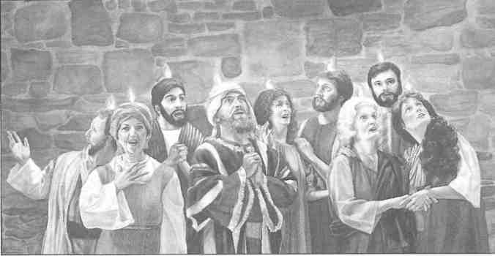
By his spirit, God carries out his judgments on men and nations. (Isaiah 30:27, 28; 59: 18, 19) And God's spirit can reach everywhere, acting for people or against them.—Psalm 139:7-12.
'Power Beyond Normal'
OD'S spirit can also supply "power beyond what is normal" to those who serve him. (2 Corinthians 4:7) This enables them to endure trials of faith or to do things they could not otherwise do.

G
For example, regarding Samson, Judges 14:6 relates: "The spirit of Yahweh seized on him, and though he had no weapon in his hand he tore the lion in pieces." (JB) Did a divine person actually enter or seize Samson, manipulating his body to do what he did? No, it was really "the power of the Lord [that] made Samson strong."—TEV.
The Bible says that when Jesus was baptized, holy spirit came down upon him appearing like a dove, not like a human form. (Mark 1:10) This active force of God enabled Jesus to heal the sick and raise the dead. As Luke 5:17 says: "The Power of the Lord [God] was behind his [Jesus'] works of healing."—JB.
God's spirit also empowered the disciples of Jesus to do miraculous things. Acts 2:1-4 relates that the disciples were assembled together at Pentecost when "suddenly there occurred from heaven a noise just like that of a rushing stiff breeze, . . . and they all became filled with holy spirit and started to speak with different tongues, just as the spirit was granting them to make utterance."
So the holy spirit gave Jesus and other servants of God the power to do what humans ordinarily could not do.
Not a Person
ARE there not, however, Bible verses that speak of the holy spirit in personal terms? Yes, but note what Catholic theologian Edmund Fortman says about this in The Triune God: "Although this spirit is often described in personal terms, it seems quite clear that the sacred writers [of the Hebrew Scriptures] never conceived or presented this spirit as a distinct person."
In the Scriptures it is not unusual for something to be personified. Wisdom is said to have children. (Luke 7:35) Sin and death are called kings. (Romans 5:14, 21) At Genesis 4:7 The New English Bible (NE) says: "Sin is a demon crouching at the door," personifying sin as a wicked spirit crouching at Cain's door. But, of course, sin is not a spirit person; nor does personifying the holy spirit make it a spirit person.

SHOULD YOU BELIEVE IN THE TRINITY?
21

Similarly, at 1 John 5:6-8 (NE) not only the spirit but also "the water, and the blood" are said to be "witnesses." But water and blood are obviously not persons, and neither is the holy spirit a person.
On the whole, the New
Testament, like the Old, speaks
of the spirit as a divine
energy or power."—A
Catholic Dictionary
In harmony with this is the Bible's general usage of "holy spirit" in an impersonal way, such as paralleling it with water and fire. (Matthew 3:11; Mark 1:8) People are urged to become filled with holy spirit instead of with wine. (Ephe-sians 5:18) They are spoken of as being filled with holy spirit in the same way they are filled with such qualities as wisdom, faith, and joy. (Acts 6:3; 11:24; 13:52) And at 2 Corinthians 6:6 holy spirit is included among a number of qualities. Such expressions would not be so common if the holy spirit were actually a person.
Then, too, while some Bible texts say that the spirit speaks , other texts show that this was actually done through liumans or angels. (Matthew 10:19, 20; Acts 4:24, 25; 28:25; Hebrews 2:2) The action of the spirit in such instances is like that of radio waves transmitting messages from one person to another far away.
At Matthew 28:19 reference is made to "the name ... of the holy spirit." But the word "name" does not always mean a personal name, either in Greek or in English. When we say "in the name of the law," we are not referring to a person. We mean that which the law stands for, its authority. Robertson's Word Pictures in the New Testament says: "The use of name (onoma) here is a common one in the Septuagint and the papyri for power or authority." So baptism 'in the name of the holy spirit' recognizes the authority of the spirit, that it is from God and functions by divine will.
The "Helper"
JESUS spoke of the holy spirit as a "helper," and he said it would teach, guide, and speak. (John 14:16, 26; 16:13) The Greek word he used for helper (para'kietos) is in the
masculine gender. So when Jesus referred to what the helper would do, he used masculine personal pronouns. (John 16:7, 8) On the other hand, when the neuter Greek word for spirit (pneu'ma) is used, the neuter pronoun "it" is properly employed.
Most Trinitarian translators hide this fact, as the Catholic New American Bible admits regarding John 14:17: "The Greek word for 'Spirit' is neuter, and while we use personal pronouns in English ('he,' 'his,' 'him'), most Greek MSS [manuscripts] employ 'it.'" So when the Bible uses masculine personal pronouns in connection with pa-ra'kletos at John 16:7, 8, it is conforming to rules of grammar, not expressing a doctrine.
No Part of a Trinity
VARIOUS sources acknowledge that the Bible does not support the idea that the holy spirit is the third person of a Trinity. For example:
The Catholic Encyclopedia: "Nowhere in the Old Testament do we find any clear indication of a Third Person."
Catholic theologian Fortman: "The Jews never regarded the spirit as a person; nor is there any solid evidence that any Old Testament writer held this view. . . . The Holy Spirit is usually presented in the Synoptics [Gospels] and in Acts as a divine force or power."
The New Catholic Encyclopedia: "The 0[ld] T[estament] clearly does not envisage God's spirit as a person . . . God's spirit is simply God's power. If it is sometimes represented as being distinct from God, it is because the breath of Yahweh acts exteriorly." It also says: "The majority of N[ew] T[estament] texts reveal God's spirit as something, not someone; this is especially seen in the parallelism between the spirit and the power of God."—Italics ours.
A Catholic Dictionary: "On the whole, the New Testament, like the Old, speaks of the spirit as a divine energy or power."

22
SHOULD YOU BELIEVE IN THE TRINITY?

Hence, neither the Jews nor the early Christians viewed the holy spirit as part of a Trinity. That teaching came centuries later. As A Catholic Dictionary notes: "The third Person was asserted at a Council of Alexandria in 362 . . . and finally by the Council of Constantinople of 381"—some three and a half cen-
turies after holy spirit filled the disciples at Pentecost!
No, the holy spirit is not a person and it is not part of a Trinity. The holy spirit is God's active force that he uses to accomplish his will. It is not equal to God but is always at his disposition and subordinate to him.

What About Trinity "Proof Texts"?

IT IS said that some Bible texts offer proof in support of the Trinity. However, when reading such texts, we should keep in mind that the Biblical and historical evidence does not support the Trinity.
Any Bible reference offered as proof must be understood in the context of the consistent teaching of the entire Bible. Very often the true meaning of such a text is clarified by the context of surrounding verses.
Three in One
THE New Catholic Encyclopedia offers three such "proof texts" but also admits: "The doctrine of the Holy Trinity is not taught in the 0[ld] T[estament]. In the N[ew] Testament] the oldest evidence is in the Pauline epistles, especially 2 Cor 13.13 [verse 14 in some Bibles], and 1 Cor 12.4-6. In the Gospels evidence of the Trinity is found explicitly only in the baptismal formula of Mt 28.19."
In those verses the three "persons" are listed as follows in The New Jerusalem Bible. Second Corinthians 13:13 (14) puts the three together in this way: "The grace of the Lord Jesus Christ, the love of God and the fellowship of the Holy Spirit be with you all." First Corinthians 12:4-6 says: "There are many different gifts, but it is always the same Spirit; there are many different ways of serving, but it is always the same Lord. There are many different forms of activity, but in everybody it is the same God who is at work in them all." And Matthew 28:19 reads: "Go, therefore, make disciples of all nations; baptise them in the name of the Father and of the Son and of the Holy Spirit."
SHOULD YOU BELIEVE IN THE TRINITY?
Do those verses say that God, Christ, and the holy spirit constitute a Trinitarian Godhead, that the three are equal in substance, power, and eternity? No, they do not, no more than listing three people, such as Tom, Dick, and Harry, means that they are three in one.
This type of reference, admits McClintock and Strong's Cyclopedia of Biblical, Theological, and Ecclesiastical Literature, "proves only that there are the three subjects named, . . . but it does not prove by itself, that all the three belong necessarily to the divine nature, and possess equal divine honor."
Although a supporter of the Trinity, that source says of 2 Corinthians 13:13 (14): "We could not justly infer that they possessed eguaJ authority, or the same nature." And of Matthew 28:18-20 it says: "This text, however, taken by itself, would not prove decisively either the personality of the three subjects mentioned, or their eqruaiity or divinity ,."
When Jesus was baptized, God, Jesus, and the holy spirit were also mentioned in the same context. Jesus "saw descending like a dove God's spirit coming upon him." (Matthew 3:16) This, however, does not say that the three are one. Abraham, Isaac, and Jacob are mentioned together numerous times, but that does not make them one. Peter, James, and John are named together, but that does not make them one either. Furthermore, God's spirit descended upon Jesus at his baptism, showing that Jesus was not anointed by spirit until that time. This being so, how could he be part of a Trinity where he had always been one with the holy spirit?Another reference that speaks of the three
23

together is found in some older Bible translations at 1 John 5:7. Scholars acknowledge, however, that these words were not originally in the Bible but were added much later. Most modern translations rightly omit this spurious verse.
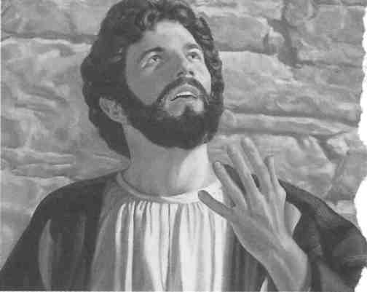
"The ancients made a wrong use of
[John 10:30] to prove that Christ
is ... of the same essence with
the Father."—Commentary
on the Gospel According
to John, by John
Calvin
Other "proof texts" deal only with the relationship between two—the Father and Jesus. Let us consider some of them ● ● .
"I and the Father Are One"
THAT text, at John 10:30, is often cited to support the Trinity, even though no third person is mentioned there. But Jesus himself showed what he meant by his being "one" with the Father. At John 17:21, 22, he prayed to God that his disciples "may all be one, just as you. Father, are in union with me and I am in union with you, that they also may be in union with us,.. . that they may be one just as we are one." Was Jesus praying that all his disciples would become a single entity? No, obviously Jesus was praying that they would be united in thought and purpose, as he and God were.—See also 1 Corinthians 1:10.
At 1 Corinthians 3:6, 8, Paul says: "I planted, Apollos watered ... He that plants and he that waters are one." Paul did not mean that he and Apollos were two persons in one; he meant that they were unified in purpose. The Greek word that Paul used here for "one" (hen) is neuter, literally "one (thing)," indicating oneness in cooperation. It is the same word that Jesus used at John 10:30 to describe his relationship with his Father. It is also the same word that Jesus used at John 17:21, 22. So when he used the word "one" {hen) in these cases, he was talking about unity of thought and purpose.
Regarding John 10:30, John Calvin (who was a Trinitarian) said in the book Commentary on the Gospel According to John: "The ancients made a wrong use of this passage to prove that Christ is ... of the same essence with the Father. For Christ does not argue about the unity of substance, but
24
about the agreement which he has with the Father."
Bight in the context of the verses after John 10:30, Jesus forcefully argued that his words were not a claim to be God. He asked the Jews who wrongly drew that conclusion and wanted to stone him: "Why do you charge me with blasphemy because I, consecrated and sent into the world by the Father, said, 'I am God's son'?" (John 10:31-36, NE) No, Jesus claimed that he was, not God the Son, but the Son of God.
"Making Himself Equal to God"?
ANOTHER scripture offered as support for the Trinity is John 5:18. It says that the Jews (as at John 10:31-36) wanted to kill Jesus because "he was also calling God his own Father, making himself equal to God."
But who said that Jesus was making himself equal to God? Not Jesus. He defended himself against this false charge in the very next verse (19): "To this accusation Jesus replied: . . . 'the Son can do nothing by himself; he can do only what he sees the Father doing.'"—IB.
By this, Jesus showed the Jews that he was not equal to God and therefore could not act on his own initiative. Can we imagine someone
SHOULD YOU BELIEVE IN THE TRINITY?
Jesus prayed to God that his disciples might "all be one," just as he and his Father "are one"
equal to Almighty God saying that he could "do nothing by himself'? (Compare Daniel 4: 34, 35.) Interestingly, the context of both John 5:18 and 10:30 shows that Jesus defended himself against false charges from Jews who, like the Trinitarians, were drawing wrong conclusions!
"Equal With God"?
AT PHILIPPIANS 2:6 the Catholic Douay Version (Dy) of 1609 says of Jesus: "Who
being in the form of God, thought it not robbery to be equal with God." The King James Version (KJ) of 1611 reads much the same. A number of such versions are still used by some to support the idea that Jesus was equal to God. But note how other translations render this verse:
1869: "who, being in the form of God, did not regard it as a thing to be grasped at to be on an equality with God." The New Testament, by G. R. Noyes.
1965: "He—truly of divine nature!—never self-confidently made himself equal to God." Das Neue Testament, revised edition, by Friedrich Pfafflin.
1968: "who, although being in the form of God, did not consider being equal to God a thing to greedily make his own." La Bibbia Concordata.
1976: "He always had the nature of God, but he did not think that by force he should try to become equal with God." Today's English Version.
1984: "who, although he was existing in God's form, gave no consideration to a seizure, namely, that he should be equal to God." New World Translation of the Holy Scriptures.
1985: "Who, being in the form of God, did not count equality with God something to be grasped." The New Jerusalem Bible.
SHOULD YOU BELIEVE IN THE TRINITY?
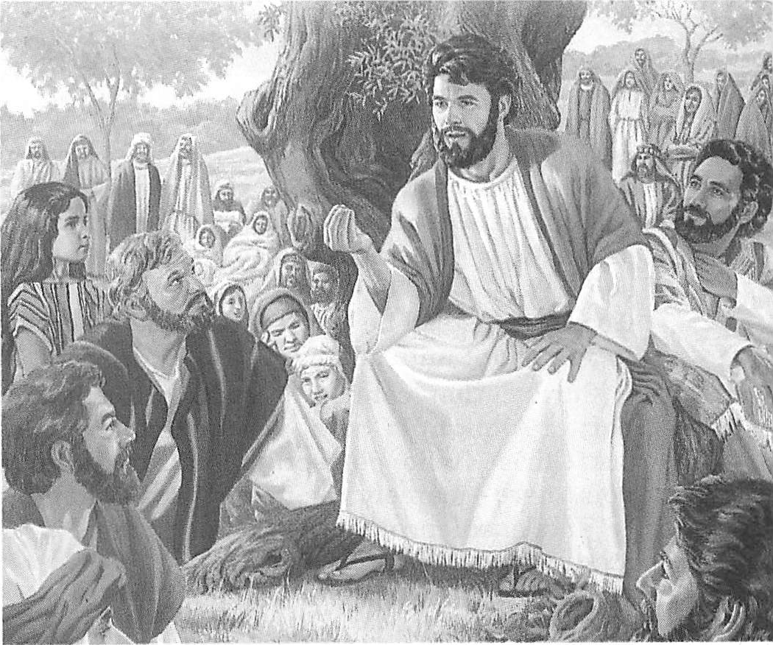
Some claim, however, that even these more accurate renderings imply that (1) Jesus already had equality but did not want to hold on to it or that (2) he did not need to grasp at equality because he already had it.
In this regard, Ralph Martin, in The Epistle of Paul to the Philippians, says of the original Greek: "It is questionable, however, whether the sense of the verb can glide from its real meaning of 'to seize', 'to snatch violently' to that of 'to hold fast.— The Expositor's Greek Testament also says: "We cannot find any passage where •apnaccu [har-pa'zo] or any of its derivatives has the sense of 'holding in possession,"retaining'. It seems invariably to mean 'seize,' 'snatch violently. Thus it is not permissible to glide from the true sense 'grasp at' into one which is totally different, 'hold fast."
From the foregoing it is apparent that the translators of versions such as the Douay and the King James are bending the rules to support Trinitarian ends. Far from saying that Jesus thought it was appropriate to be equal to God, the Greek of Philippians 2:6, when read objectively, shows just the opposite, that Jesus did not think it was appropriate.
The context of the surrounding verses (3-5, 7, 8, Dy) makes it clear how verse 6 is to be understood. The Philippians were urged: "In humility, let each esteem others better than themselves." Then Paul uses Christ as the outstanding example of this attitude: "Let this mind be in you, which was also in Christ
25
Jesus." What "mind"? To 'think it not robbery to be equal with God'? No, that would be just the opposite of the point being made! Rather, Jesus, who 'esteemed God as better than himself,' would never 'grasp for equality with God,' but instead he "humbled himself, becoming obedient unto death."
Surely, that cannot be talking about any part of Almighty God. It was talking about Jesus Christ, who perfectly illustrated Paul's point here—namely the importance of humility and obedience to one's Superior and Creator, Jehovah God. ● 3 additional scriptures.
"I Am"
AT JOHN 8:58 a number of translations, for instance The Jerusalem Bible, have Jesus saying: "Before Abraham ever was, I Am." Was Jesus there teaching, as Trinitarians assert, that he was known by the title "I Am"? And, as they claim, does this mean that he was Jehovah of the Hebrew Scriptures, since the King James Version at Exodus 3:14 states: "God said unto Moses, I AM THAT I AM"?
At Exodus 3:14 [KJ) the phrase "I AM" is used as a title for God to indicate that he really existed and would do what he promised. The Pentateuch and Haftorahs, edited by Dr. J. H. Hertz, says of the phrase: "To the Israelites in bondage, the meaning would be, 'Although He has not yet displayed His power towards you, He will do so; He is eternal and will certainly redeem you.' Most moderns follow Rashi [a French Bible and Talmud commentator] in rendering [Exodus 3:14] T will be what I will be.'"
The expression at John 8:58 is quite differ-
ent from the one used at Exodus 3:14. Jesus did not use it as a name or a title but as a means of explaining his prehuman existence. Hence, note how some other Bible versions render John 8:58:
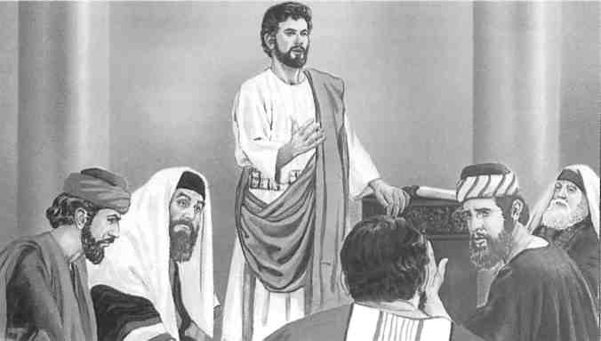
Jesus showed the Jews that he was not equal to God, saying that he could 'do nothing by himself but only what he saw the Father doing'
1869: "From before Abraham was, I have been." The New Testament, by G. R. Noyes.
1935: "I existed before Abraham was born!" The Bible—An American Translation, by J. M. P. Smith and E. J. Goodspeed.
1965: "Before Abraham was born, I was already the one that I am." Das Neue Testament, by JOrg Zink.
1981: "I was alive before Abraham was born!" The Simple English Bible.
1984: "Before Abraham came into existence, I have been." New World Translation of the Holy Scripturesthe real thought of the Greek used here is that God's created "firstborn," Jesus, had existed long before Abraham was born. —Colossians 1:15; Proverbs 8:22, 23, 30; Revelation 3:14.
Again, the context shows this to be the correct understanding. This time the Jews wanted to stone Jesus for claiming to "have seen Abraham" although, as they said, he was not yet 50 years old. (Verse 57) Jesus' natural response was to tell the truth about his age. So he naturally told them that he "was alive before Abraham was born!"—The Simple English Bible.
"The Word Was God"
AT JOHN 1:1 the King James Version reads: "In the beginning was the Word, and the Word was with God, and the Word

was God." Trinitarians claim that this means that "the Word" (Greek, ho lo'gos) who came to earth as Jesus Christ was Almighty God himself.
Someone who is "with"
another person cannot
also be that other
person
Note, however, that here again the context lays the groundwork for accurate understanding. Even the King James Version says, "The Word was with God." (Italics ours.) Someone who is "with" another person cannot be the same as that other person. In agreement with this, the Journal of Biblical Literature, edited by Jesuit Joseph A. Fitzmyer, notes that if the latter part of John 1:1 were interpreted to mean "the" God, this "would then contradict the preceding clause," which says that the Word was with God.
Notice, too, how other translations render this part of the verse:
1808: "and the word was a god." The New Testament in an Improved Version, Upon the Basis of Archbishop Newcome's New Translation: With a Corrected Text.
1864: "and a god was the word." The Emphatic Diaglott, interlinear reading, by Benjamin Wilson.
1928: "and the Word was a divine being." La Bible du Centenaire, L'Evangile selon Jean, by Maurice Goguel.
1935: "and the Word was divine." The Bible —An American Translation, by J. M. P. Smith and E. J. Goodspeed.
1946: "and of a divine kind was the Word." Das Neue Testament, by Ludwig Thimme.
1950: "and the Word was a god." New World Translation of the Christian Greek Scriptures.
1958: "and the Word was a God." The New Testament, by James L. Tomanek.
1975: "and a god (or, of a divine kind) was the Word." Das Evangelium nach Johannes, by Siegfried Schulz.
1978: "and godlike kind was the Logos." Das Evangelium nach Johannes, by Johannes Schneider.
At John 1:1 there are two occurrences of the Greek noun the•os' (god). The first occurrence refers to Almighty God, with whom the Word was ("and the Word [lo'gos] was with
SHOULD YOU BELIEVE IN THE TRINITY?
God [a form of the•os1"). This first the•os' is preceded by the word ton (the), a form of the Greek definite article that points to a distinct identity, in this case Almighty God ("and the Word was with [the] God").
On the other hand, there is no article before the second the•os' at John 1:1. So a literal translation would read, "and god was the Word." Yet we have seen that many translations render this second the•os' (a predicate noun) as "divine," "godlike," or "a god." On what authority do they do this?
The Koine Greek language had a definite article ("the"), but it did not have an indefinite article ("a" or "an"). So when a predicate noun is not preceded by the definite article, it may be indefinite, depending on the context.
The Journal of Biblical Literature says that expressions "with an anarthrous [no article] predicate preceding the verb, are primarily qualitative in meaning." As the Journal notes, this indicates that the lo'gos can be likened to a god. It also says of John 1:1: "The qualitative force of the predicate is so prominent that the noun [the•osi cannot be regarded as definite."
So John 1:1 highlights the quality of the Word, that he was "divine," "godlike," "a god," but not Almighty God. This harmonizes with the rest of the Bible, which shows that Jesus, here called "the Word" in his role as God's Spokesman, was an obedient subordinate sent to earth by his Superior, Almighty God.
There are many other Bible verses in which almost all translators in other languages consistently insert the article "a" when translating Greek sentences with the same structure. For example, at Mark 6:49, when the disciples saw Jesus walking on water, the King James Version says: "They supposed it had been a spirit." In the Koine Greek, there is no "a" before "spirit." But almost all translations in other languages add an "a" in order to make the rendering fit the context. In the same way, since John 1:1 shows that the Word was with God, he could not be God but was "a god," or "divine."

Joseph Henry Thayer, a theologian and scholar who worked on the American Standard Version, stated simply: "The Logos was divine, not the divine Being himself." And Jesuit John L. McKenzie wrote in his Dictionary of the Bible: "Jn 1:1 should rigorously be translated . . . 'the word was a divine being.'"
The Logos was divine, not
the divine Being himself."
—Joseph Henry Thayer,
Bible scholar
Violating a Rule?
SOME claim, however, that such renderings violate a rule of Koine Greek grammar published by Greek scholar E. C. Colwell back in 1933. He asserted that in Greek a predicate noun "has the [definite] article when it follows the verb; it does not have the [definite] article when it precedes the verb." By this he meant that a predicate noun preceding the verb should be understood as though it did have the definite article ("the") in front of it. At John 1:1 the second noun (the-os 0, the predicate, precedes the verb—"and [the-os'] was the Word." So, Colwell claimed, John 1:1 should read "and [the] God was the Word."
But consider just two examples found at John 8:44. There Jesus says of the Devil: "That one was a manslayer" and "he is a liar." Just as at John 1:1, the predicate nouns ("manslayer" and "liar") precede the verbs ("was" and "is") in the Greek. There is no indefinite article in front of either noun because there was no indefinite article in Koine Greek. But most translations insert the word "a" because Greek grammar and the context require it.—See also Mark 11:32; John 4:19; 6:70; 9:17; 10:1; 12:6.
Colwell had to acknowledge this regarding the predicate noun, for he said: "It is indefinite ["a" or "an"] in this position only when the context demands it." So even he admits that when the context requires it, translators may insert an indefinite article in front of the noun in this type of sentence structure.
Does the context require an indefinite article at John 1:1? Yes, for the testimony of the entire Bible is that Jesus is not Almighty God. Thus, not Colwell's questionable rule of grammar, but context should guide the translator in
28
such cases. And it is apparent from the many translations that insert the indefinite article "a" at John 1:1 and in other places that many scholars disagree with such an artificial rule, and so does God's Word.
No Conflict
DOES saying that Jesus Christ is "a god" conflict with the Bible's teaching that there is only one God? No, for at times the Bible employs that term to refer to mighty creatures. Psalm 8:5 reads: "You also proceeded to make him [man] a little less than godlike ones [Hebrew, 'elohim']," that is, angels. In Jesus' defense against the charge of the Jews, that he claimed to be God, he noted that "the Law uses the word gods of those to whom the word of God was addressed," that is, human judges. (John 10:34, 35, JB; Psalm 82:1-6) Even Satan is called "the god of this system of things" at 2 Corinthians 4:4.
Jesus has a position far higher than angels, imperfect men, or Satan. Since these are referred to as "gods," mighty ones, surely Jesus can be and is "a god." Because of his unique position in relation to Jehovah, Jesus is a "Mighty God."—John 1:1; Isaiah 9:6.
But does not "Mighty God" with its capital letters indicate that Jesus is in some way equal to Jehovah God? Not at all. Isaiah merely prophesied this to be one of four names that Jesus would be called, and in the English language such names are capitalized. Still, even though Jesus was called "Mighty," there can be only one who is "Almighty." To call Jehovah God "Almighty" would have little significance unless there existed others who were also called gods but who occupied a lesser or inferior position.
The Bulletin of the John Rylands Library in England notes that according to Catholic theologian Karl Rahner, while the-os' is used in scriptures such as John 1:1 in reference to Christ, "in none of these instances is 'theos' used in such a manner as to identify Jesus with him who elsewhere in the New Testament figures as 'ho Theos,' that is, the Supreme God." And the Bulletin adds: "If the New Testament writers believed it vital that
SHOULD YOU BELIEVE IN THE TRINITY?
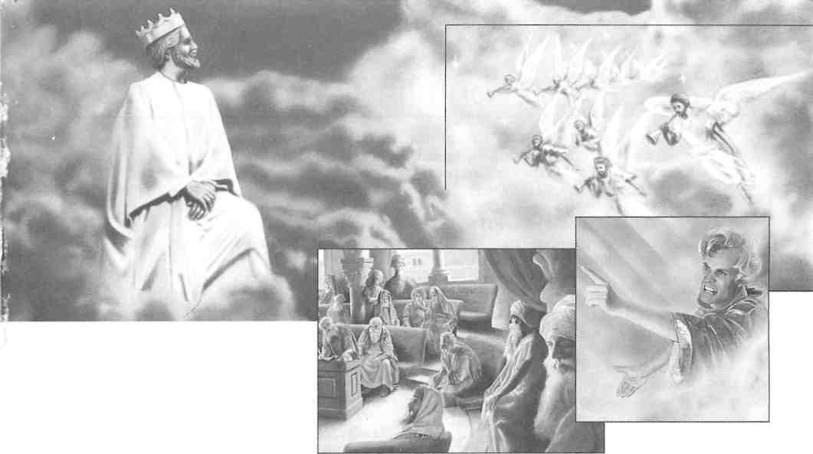
Since the Bible calls humans, angels, even Satan, "gods," or powerful ones, the superior Jesus in heaven can properly be called "a god"

the faithful should confess Jesus as 'God', is the almost complete absence of just this form of confession in the New Testament explicable?"

But what about the apostle Thomas' saying, "My Lord and my God!" to Jesus at John 20:28? To Thomas, Jesus was like "a god," especially in the miraculous circumstances that prompted his exclamation. Some scholars suggest that Thomas may simply have made an emotional exclamation of astonishment, spoken to Jesus but directed to God. In either case, Thomas did not think that Jesus was Almighty God, for he and all the other apostles knew that Jesus never claimed to be God but taught that Jehovah alone is "the only true God."—John 17:3.
Again, the context helps us to understand this. A few days earlier the resurrected Jesus had told Mary Magdalene to tell the disciples: "I am ascending to my Father and your Father and to my God and your God." (John 20:17) Even though Jesus was already resurrected as a mighty spirit, Jehovah was still his God. And Jesus continued to refer to Him as such even in the last book of the Bible, after he was glorified. —Revelation 1:5, 6; 3:2, 12.
Just three verses after Thomas' exclamation, at John 20:31, the Bible further clarifies the
SHOULD YOU BELIEVE IN THE TRINITY?
matter by stating: "These have been written down that you may believe that Jesus is the Christ the Son of God," not that he was Almighty God. And it meant "Son" in a literal way, as with a natural father and son, not as some mysterious part of a Trinity Godhead.
Must Harmonize With the Bible
IT IS claimed that several other scriptures support the Trinity. But these are similar to those discussed above in that, when carefully examined, they offer no actual support. Such texts only illustrate that when considering any claimed support for the Trinity, one must ask: Does the interpretation harmonize with the consistent teaching of the entire Bible—that Jehovah God alone is Supreme? If not, then the interpretation must be in error.
We also need to keep in mind that not even so much as one "proof text" says that God, Jesus, and the holy spirit are one in some mysterious Godhead. Not one scripture anywhere in the Bible says that all three are the same in substance, power, and eternity. The Bible is consistent in revealing Almighty God, Jehovah, as alone Supreme, Jesus as his created Son, and the holy spirit as God's active force.
29
Worship God on His Terms

JESUS said in prayer to God: "This means everlasting life, their taking in knowledge of you, the only true God, and of the one whom you sent forth, Jesus Christ." (John 17:3) What kind of knowledge? "[God's] will is that all sorts of men should be saved and come to an accurate knowledge of truth." (1 Timothy 2:4) The Amplified Bible renders the latter phrase this way: "Know precisely and correctly the [divine] Truth."
So God wants us to know him and his purposes accurately, in conformity with divine truth. And God's Word, the Holy Bible, is the source of that truth. (John 17:17; 2 Timothy 3:16, 17) When people learn accurately what the Bible says about God, then they will avoid being like those mentioned at Romans 10:2, 3, who had "a zeal for God; but not according to accurate knowledge." Or like the Samaritans, to whom Jesus said: "You worship what you do not know."—John 4:22.
Therefore, if we want God's approval, we need to ask ourselves: What does God say about himself? How does he want to be worshiped? What are his purposes, and how should we fit in with them? An accurate knowledge of the truth gives us the right answers to such questions. Then we can worship God on his terms.
Dishonoring God
wyHOSE honoring me I shall honor," says J. God. (1 Samuel 2:30) Does it honor God to call anyone his equal? Does it honor him to call Mary "the mother of God" and the "Mediatrix . . . between the Creator and His creatures," as does the New Catholic Encyclopedia? No, those ideas insult God. No one is his equal; nor did he have a fleshly mother, since Jesus was not God. And there is no "Mediatrix," for God has appointed only "one mediator between God and men," Jesus.—1 Timothy 2:5; 1 John 2:1, 2.
Beyond a doubt, the Trinity doctrine has confused and diluted people's understanding of God's true position. It prevents people from
accurately knowing the Universal Sovereign, Jehovah God, and from worshiping him on his terms. As theologian Hans Rung said: "Why should anyone want to add anything to the notion of God's oneness and uniqueness that can only dilute or nullify that oneness and uniqueness?" But that is what belief in the Trinity has done.
Those who believe in the Trinity are not "holding God in accurate knowledge." (Romans 1:28) That verse also says: "God gave them up to a disapproved mental state, to do the things not fitting." Verses 29 to 31 list some of those 'unfitting' things, such as 'murder, strife, being false to agreements, having no natural affection, merciless.' Those very things have been practiced by religions that accept the Trinity.
For instance, Trinitarians have often persecuted and even killed those who rejected the Trinity doctrine. And they have gone even further. They have killed their fellow Trinitarians in wartime. What could be more 'unfitting' than Catholics killing Catholics, Orthodox killing Orthodox, Protestants killing Protestants—all in the name of the same Trinitarian God?
Yet, Jesus plainly said: "By this all will know that you are my disciples, if you have love among yourselves." (John 13:35) God's Word expands on this, saying: "The children of God and the children of the Devil are evident by this fact: Everyone who does not carry on righteousness does not originate with God, neither does he who does not love his brother." It likens those who kill their spiritual brothers to "Cain, who originated with the wicked one [Satan] and slaughtered his brother."— 1 John 3:10-12.
Thus, the teaching of confusing doctrines about God has led to actions that violate his laws. Indeed, what has happened throughout Christendom is what Danish theologian Soren Kierkegaard described: "Christendom has done away with Christianity without being quite aware of it."

30
SHOULD YOU BELIEVE IN THE TRINITY?

This centuries-old sculpture in France depicts the coronation of the "virgin" Mary by the Trinity. Belief in the Trinity led to veneration of Mary as the "Mother of God"
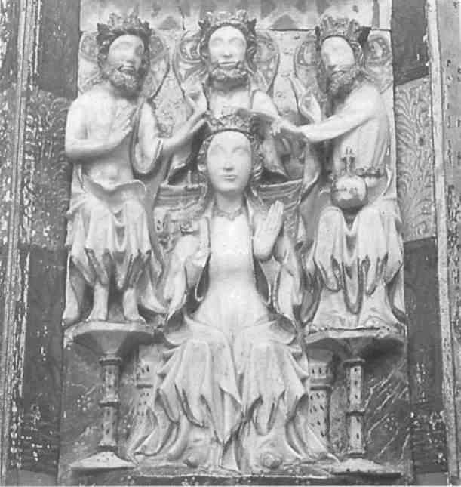
Christendom's spiritual condition fits what the apostle Paul wrote: "They publicly declare they know God, but they disown him by their works, because they are detestable and disobedient and not approved for good work of any sort."—Titus 1:16.
Soon, when God brings this present wicked system of things to its end, Trinitarian Christendom will be called to account. And she will be judged adversely for her God-dishonoring actions and doctrines.—Matthew 24: 14, 34; 25:31-34, 41, 46; Revelation 17:1-6, 16; 18:1-8, 20, 24; 19:17-21.
Reject the Trinity
THERE can be no compromise with God's truths. Hence, to worship God on his terms means to reject the Trinity doctrine. It contradicts what the prophets, Jesus, the apostles, and the early Christians believed and taught. It contradicts what God says about himself in his own inspired Word. Thus, he counsels: "Acknowledge that I alone am God and that there is no one else like me."—Isaiah 46:9, TEV.
God's interests are not served by making him confusing and mysterious. Instead, the more that people become confused about God and his purposes, the better it suits God's Adversary, Satan the Devil, the 'god of this world.' It is he who promotes such false doctrines to 'blind the minds of unbelievers.'
(2 Corinthians 4:4) And the Trinity doctrine also serves the interests of clergymen who want to maintain their hold on people, for they make it appear as though only theologians can understand it.—See John 8:44.
Accurate knowledge of God brings great relief. It frees us from teachings that are in conflict with God's Word and from organizations that have apostatized. As Jesus said: "You will know the truth, and the truth will set you free."—John 8:32.
By honoring God as supreme and worshiping him on his terms, we can avoid the judgment that he will soon bring on apostate Christendom. Instead, we can look forward to God's favor when this system ends: "The world is passing away and so is its desire, but he that does the will of God remains forever." — 1 John 2:17.

Picture Credits

Listed by location, page, and number: Church of Tagnon, France, page 10, (7). Collegiate of Montreal, Yonne, France, page 31. Musee des Beaux-Arts de Troyes, page 2, (right). Musee du Louvre, Paris, page 10, (1), (3).
Musee Guimet, Paris, page 10, (5). Musees Nationaux, France, page 10, (2). Museo Bardini, Florence, page 10, (8). Museo Egizio, Turin, page 2, (left). Scala New York/Florence, page 8.

Live Forever in Paradise on Earth
God promises eternal life to those who honor him. "The righteous themselves will possess the earth, and they will reside forever upon it," his Word assures us.—Psalm 37:29.
Yet, to be counted among "the righteous," you need to do more than become informed about the Trinity teaching. You need to progress in knowledge about God. Jehovah's Witnesses will be happy to help you, if you are not already receiving that help. Just write to Watch Tower at the appropriate address listed below, requesting further information or that one of Jehovah's Witnesses come to your home and regularly study the Bible with you free of charge.



ALASKA 99507: 2552 East 48th Ave., Anchorage. AUSTRALIA: Box 280, Ingleburn, N.S.W. 2565. BAHAMAS: Box N-1247, Nassau, N.P. BARBADOS: Fontabelle Rd, Bridgetown. BELIZE: Box 257, Belize City. CANADA: Box 4100, Halton Hills (Georgetown), Ontario L7G 4Y4. ENGLAND: The Ridgeway, London NW7 1RN. FIJI: Box 23, Suva. GERMANY: Niederselters, Am Steinfels, D-65618 Sellers. GHANA: Box 760, Accra. GUAM 96913: 143 Jehovah St., Barrigada. GUYANA: 50 Brickdam, Georgetown 16. HAWAII 96819: 2055 Kam IV Rd., Honolulu. HONG KONG: 4 Kent Road, Kowloon Tong. INDIA: Post Bag 10, Lonavla, Pune Dis„ Mah. 410 401. IRELAND: 29A Jamestown Road, Finglas, Dublin 11. JAMAICA: Box 180, Kingston 10. JAPAN: 1271 Nakashinden, Ebina City, Kanagawa Pref., 243-04. KENYA: Box 47788, Nairobi. LEEWARD ISLANDS: Box 119, St. Johns, Antigua. LIBERIA: P.O. Box 10-0380, 1000 Monrovia 10. MALAYSIA: 95 Bukit Beruang Heights, Jalan Bukit Beruang, 75450 Melaka. NEW ZEALAND: P.O. Box 142, Manurewa. NIGERIA: P.M.B. 1090, Benin City, Edo State. PAKISTAN: 197-A Ahmad Block, New Garden Town, Lahore 54600. PANAMA: Apartado 6-2671, Zona 6A, El Dorado. PAPUA NEW GUINEA: Box 636, Boroko, NCD 111. PHILIPPINES, REPUBLIC OF: P. O. Box 2044,1099 Manila. SIERRA LEONE, WEST AFRICA: P. O. Box 136, Freetown. SOUTH AFRICA: Private Bag X2067, Krugersdorp, 1740. SWITZERLAND: P.O. Box 225, CH-3602 Thun. TRINIDAD AND TOBAGO, REP. OF: Lower Rapsey Street & Laxmi Lane, Curepe. UNITED STATES OF AMERICA: 25 Columbia Heights, Brooklyn, NY 11201-2483. WESTERN SAMOA: P. O. Box 673, Apia. ZAMBIA: Box 33459, Lusaka 10101. ZIMBABWE: 35 Fife Avenue, Harare.

DO NOT USE THIS AS A WITNESSING POINT AT THIS TIME. If the Great Crowd is the Other Sheep then it should be clearly and consistently persistently presented in the bible. ● See article on other sheep. Since the Bible can 'set things straight/ it should clearly reveal information about a matter as fundamental as the Trinity is claimed to be. But do theologians and historians themselves say that it is clearly a Bible teaching? Basically this entire page can also apply to the theology of the Great Crowd and the Other Sheep. Actually, Other Sheep only appears once in the entire bible and it never appears with Great Crowd.
Hopkins is another flaming Christianity Trasher who also said: "Finally, the life, temptation, miracles, parables, and even the disciples of Jesus have been derived directly from Buddhism." So Hopkins thinks that Trinity AND most of the Watchtower doctrines were derived from Buddhism! Wow! A very convincing proof indeed. Why quote these Christianity Trashers!
It should be clear from such a title that this was no dispassionate work of scholarship, but a polemical work attacking traditional Christian beliefs.
Jehovah’s Witnesses, like Catholics firmly believe in the false doctrine called "doctrinal development". Both groups promote and believe things that are not found in the Bible. Both are "salvation by organization" religions whose leaders have exclusive direct channels to God. Jehovah’s Witnesses have a "new light" or "brighter light" theology where God reveals through the Watchtower new things never before understood. But herein lay the hypocritical paradox for Jw’s in regard to Trinity doctrine. How can Jw’s reject "doctrinal development" of the first 3 centuries yet teach they have the doctrinal development in the 20th century? Why did God only start "new light getting brighter" when Charles T Russell proclaimed it so in the late 1800’s. In other words, Jw’s firmly believe in doctrinal development in the 20th century, how can they deny it at Nicea in 325 AD? We of course maintain that doctrinal development is a false teaching and believe the Bible is all sufficient and complete! Therefore, we do not defend the Nicene creed or the Athanasius creed, but are content to simply prove the deity of the uncreated Christ and the personality of the Holy Spirit. Nevertheless, the rejection of Catholic doctrinal development, while teaching the identical thing, is hypocritical!
Antitrinitarians during the past three centuries have commonly maintained that the Trinity was borrowed from pagan beliefs. It is possible to quote from many scholarly and not-so-scholarly sources to this effect. The JW booklet quotes a number of sources that argue, or in some cases seem to imply, that the Trinity was a pagan notion that corrupted the Christian faith (pages. 9, 11-12). It also reproduces pictures of various pagan "triads," or groups of three gods, and places them alongside pictures of Christian artwork depicting or symbolizing the Trinity (pages. 2, 10). There are a number of problems with this argument. First, at least some of the sources quoted by the booklet have been misrepresented. For example, the Encyclopaedia of Religion and Ethics is quoted in its descriptions of some "trinitarian" parallels in Egyptian religion and Neoplatonic philosophy. But in context the encyclopedia is discussing similar notions, not identifying sources or influences of the Christian Trinity. ● Influence 2
Henotheism (from the Greek heis theos or “one god”) refers to religious belief systems that accept the existence of many gods (such as polytheism) but worship one deity as supreme. Such belief systems have been found throughout history and across the world's cultures. Henotheism" as a term is not widely used by the general public but it has featured prominently as a point of discussion in academic debates about the nature and development of religion.
By the same logic 1 John 5:7 says “For there are three that bear record in heaven, the Father, the Word, and the Holy Ghost:”. The Father and son are persons; therefore the Holy Spirit must be a person.
John 16:13 Howbeit when he, the Spirit of truth, is come, he will guide you into all truth: for he shall not speak of himself; but whatsoever he shall hear, that shall he speak: and he will show you things to come. Revelation 2:7 He that hath an ear, let him hear what the Spirit saith unto the churches; To him that overcometh will I give to eat of the tree of life, which is in the midst of the paradise of God.
In sum, these arguments show not that the Holy Spirit is an impersonal force, but that he acts in ways that are not easily pictured as the actions of a human being. Because the Holy Spirit works in the inner beings of countless individuals, works invisibly, and generally goes unnoticed, he invites comparison to impersonal forces in figures of speech and symbolic manifestations. But that he is not himself an impersonal force has been clearly revealed through the teaching of Jesus Christ in John 14-16, Mark 3, Matthew 28:19, and elsewhere.
In isolation, this is probably true. But the Cyclopaedia says, in the first part of the same sentence, that "we might infer… the personality of the Holy Spirit."³

